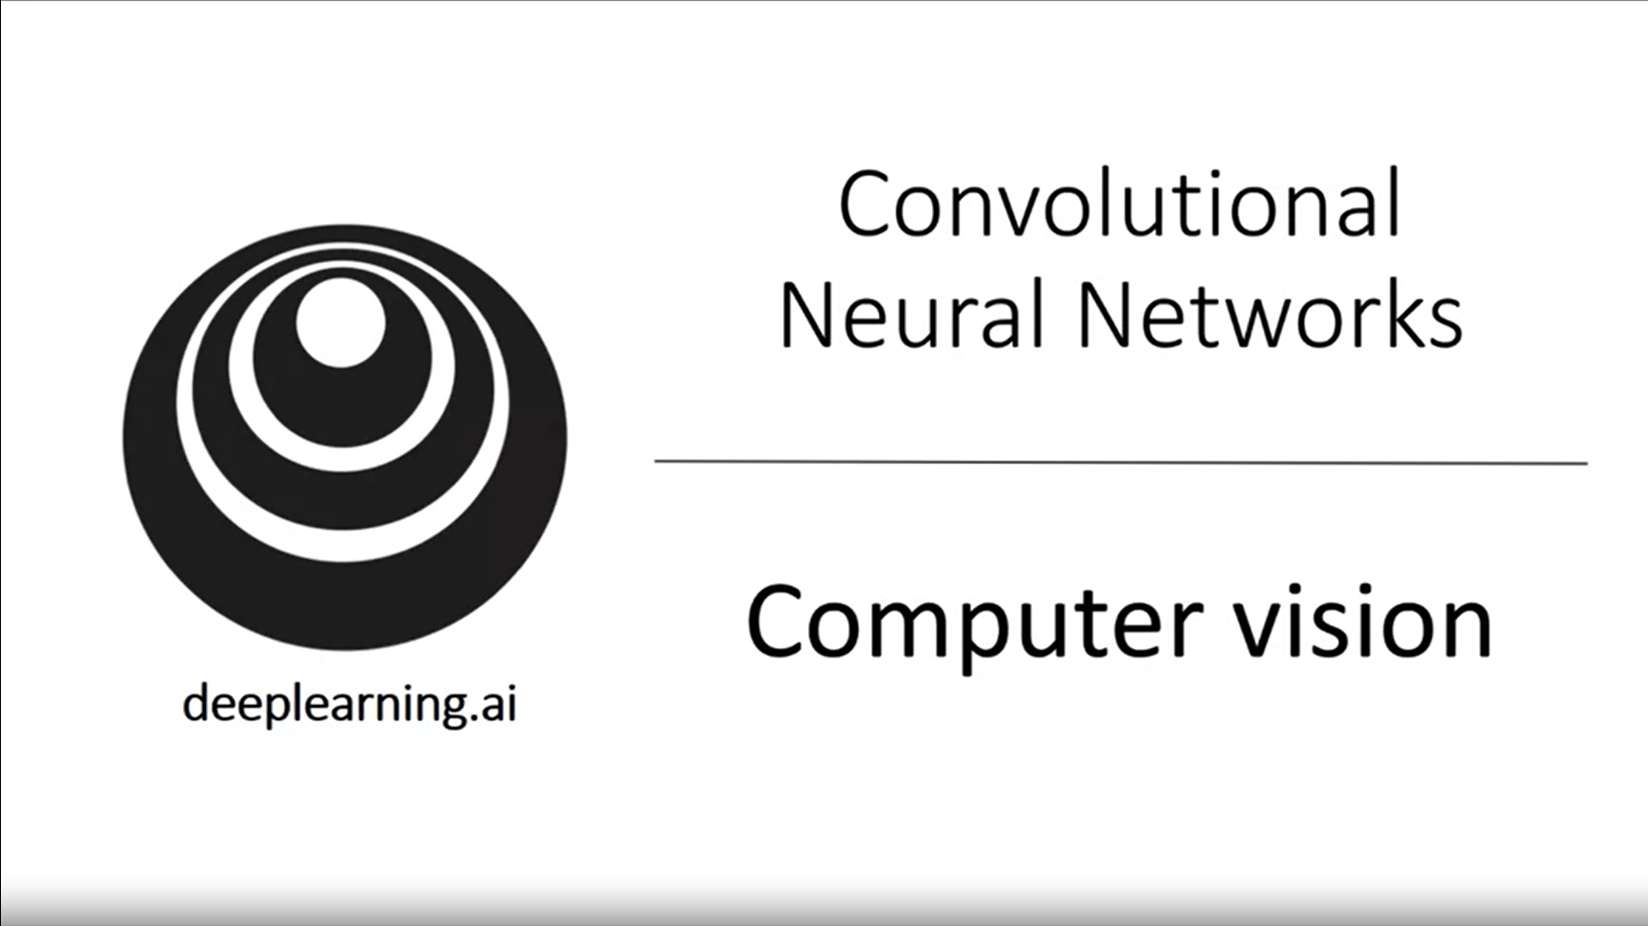

Computer vision is one of the areas which has been advancing rapidly thanks to deep learning.

Examples: self-driving cars, face recognition, apps including pictures, art generation (brand new applications).

Computer vision community has been very creative in coming up with new neural network architectures. This also inspires cross-fertilization to other areas (such as nlp, speech recognition).

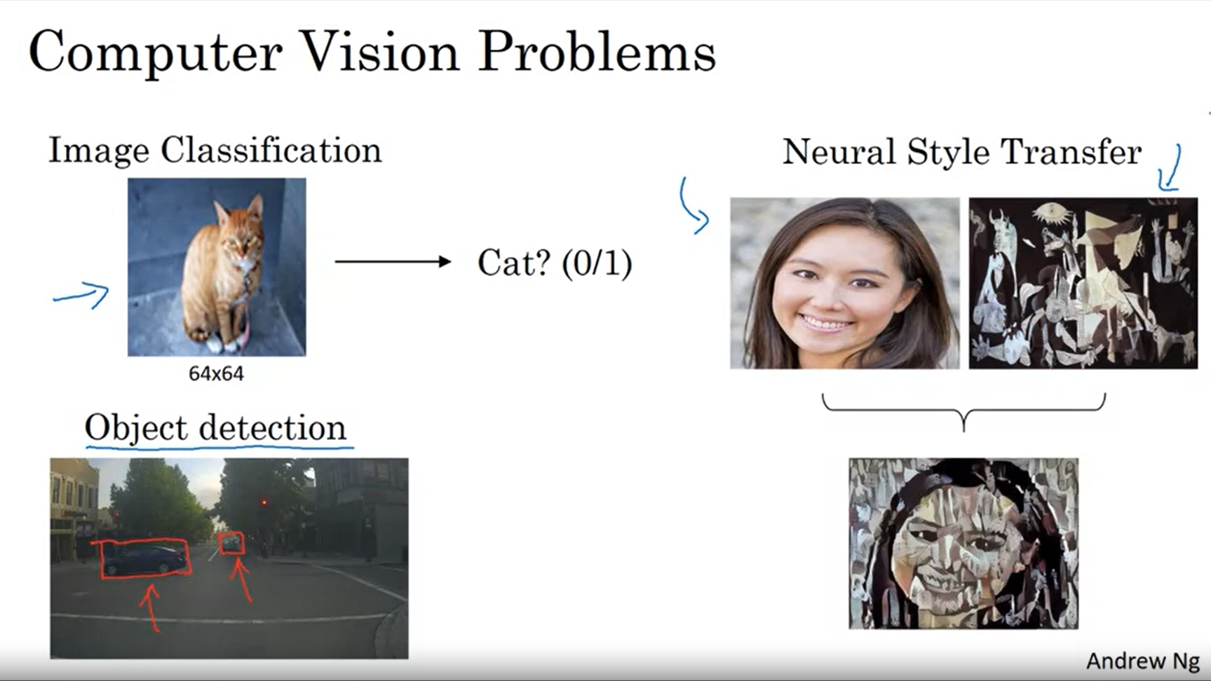

In object detection we also need to locate the objects through bounding boxes.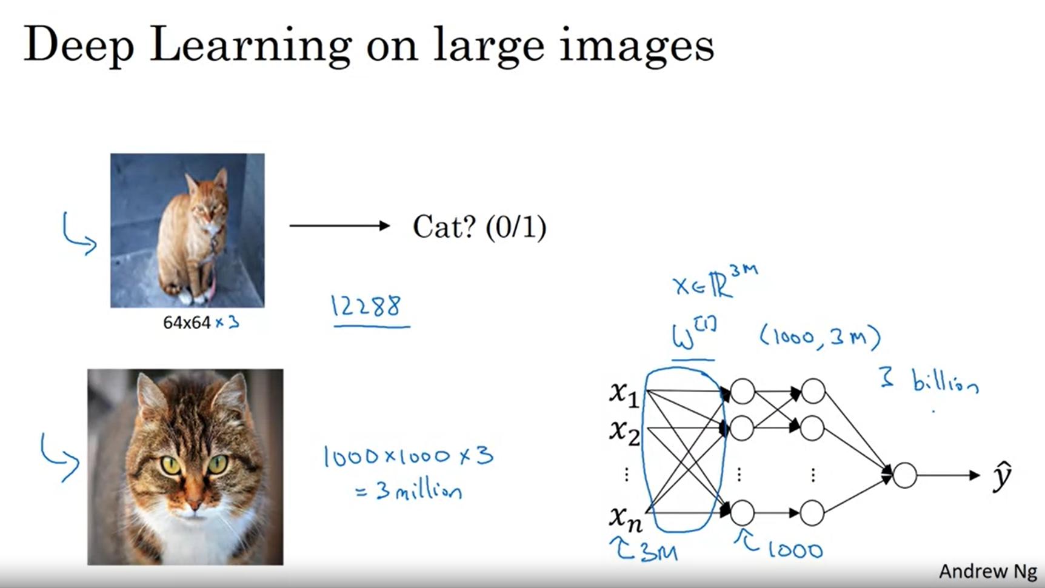

One of the challenges of computer vision is that the inputs can get really big. X would be 3mio-dimensional for a high resolution image.

With a standard vanilla network this would create lots of parameters. This will result in likely overfitting and very high memory requirements.

We will need the convolution operation to make this more tangible.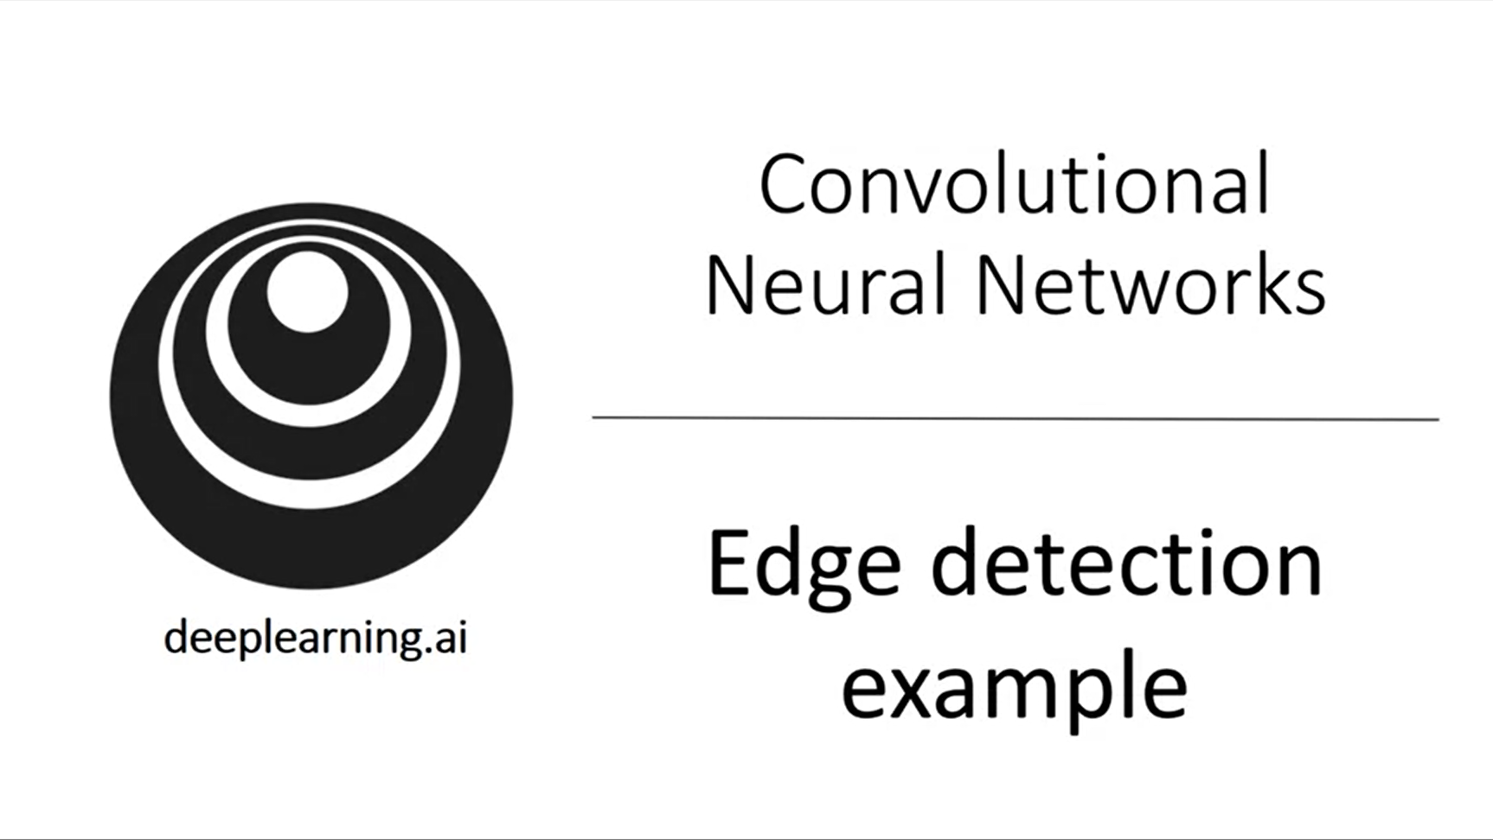

Let’s look at the fundamental building blocks of the convolution operation (motivating example: edge detection).

Earlier layers of a network: edges; then parts of objects; then complete objects.

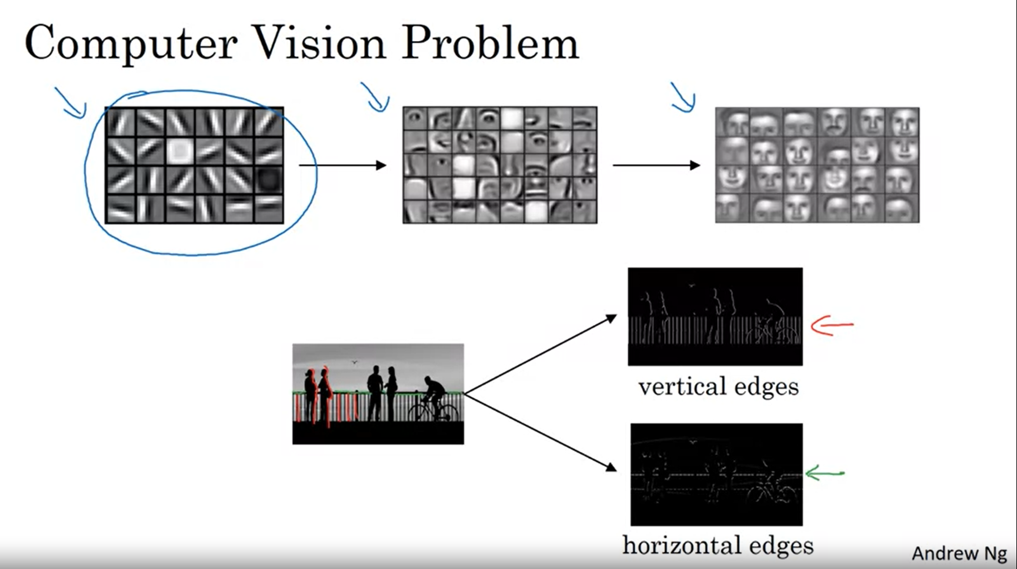

Greyscale image (6x6x1)

Always paste the filter on top of the current region and calculate the element-wise product and add them up.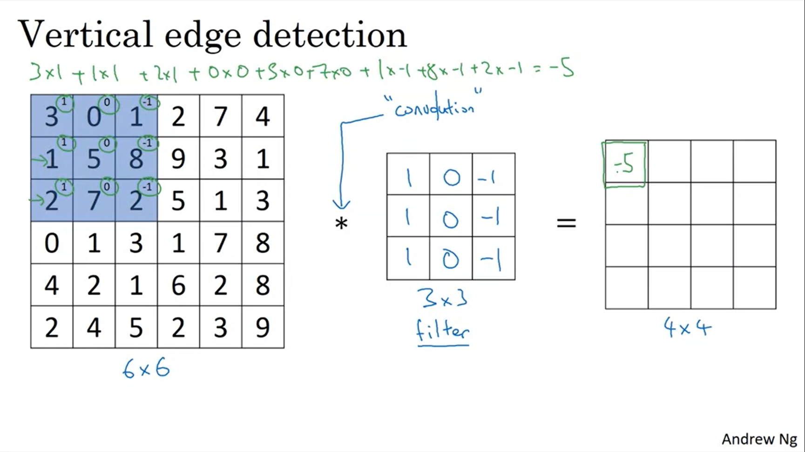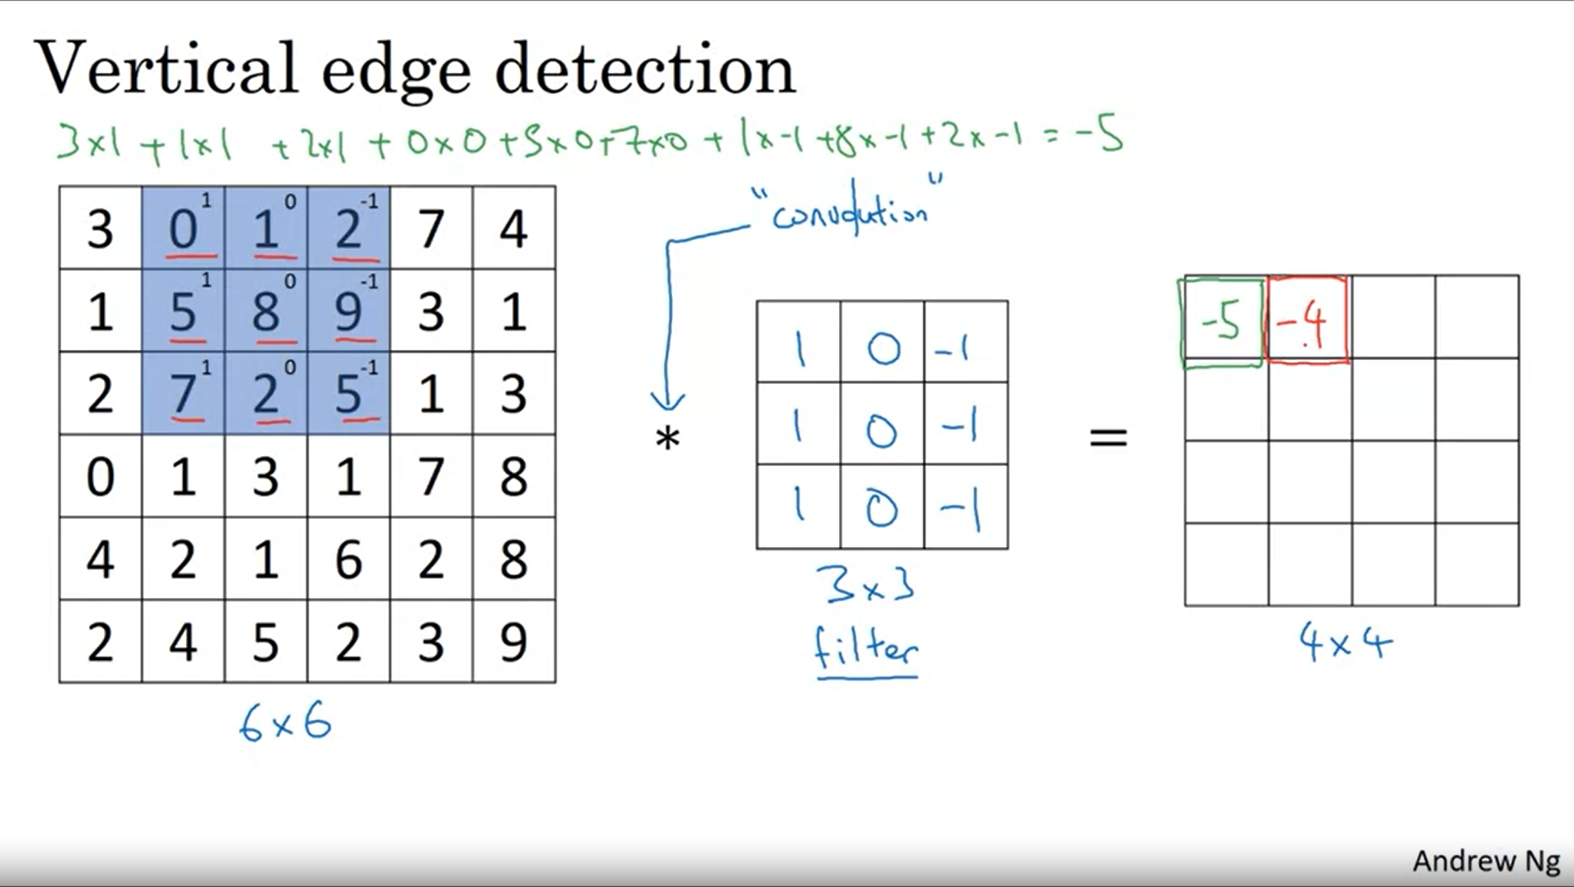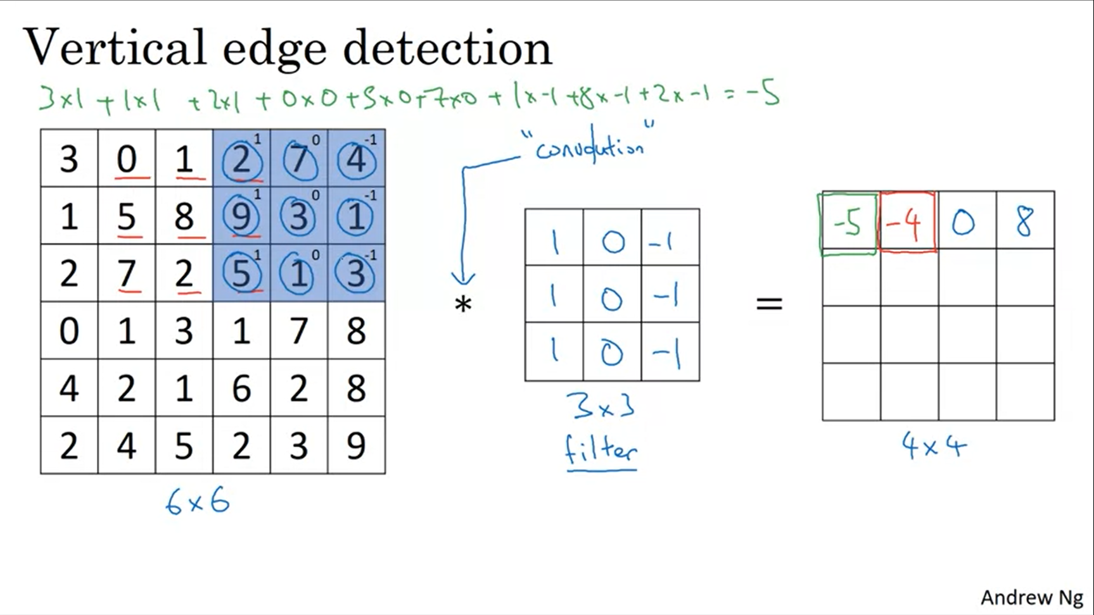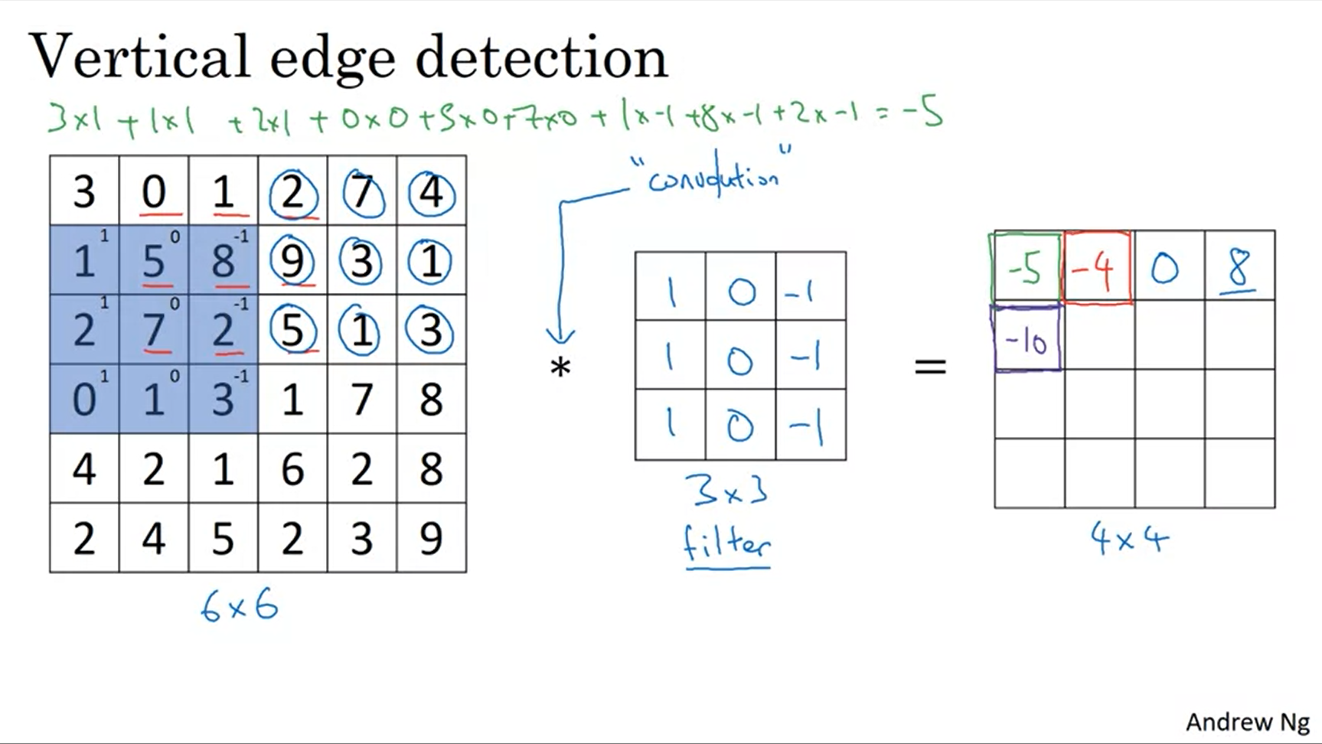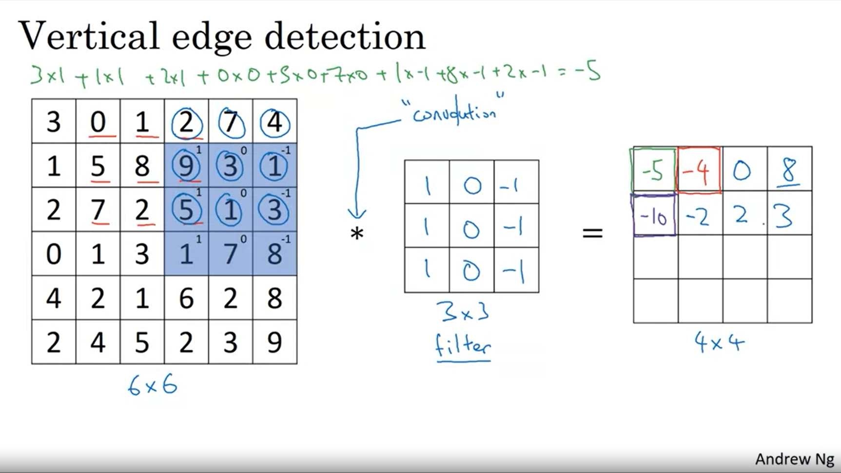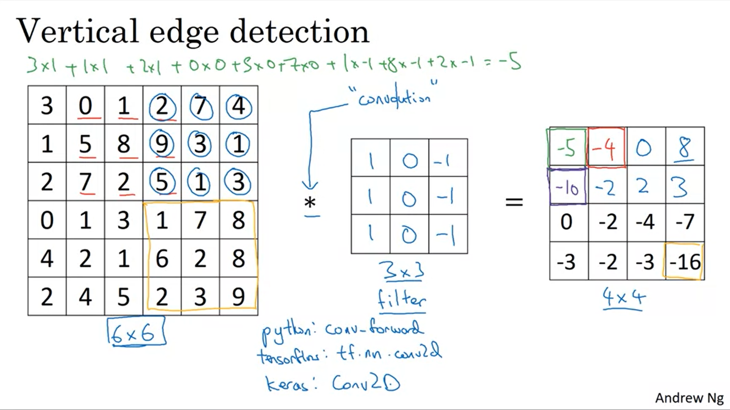

In practice most programming languages have a particular function for the convolution operation.

Why does this detect vertical edges?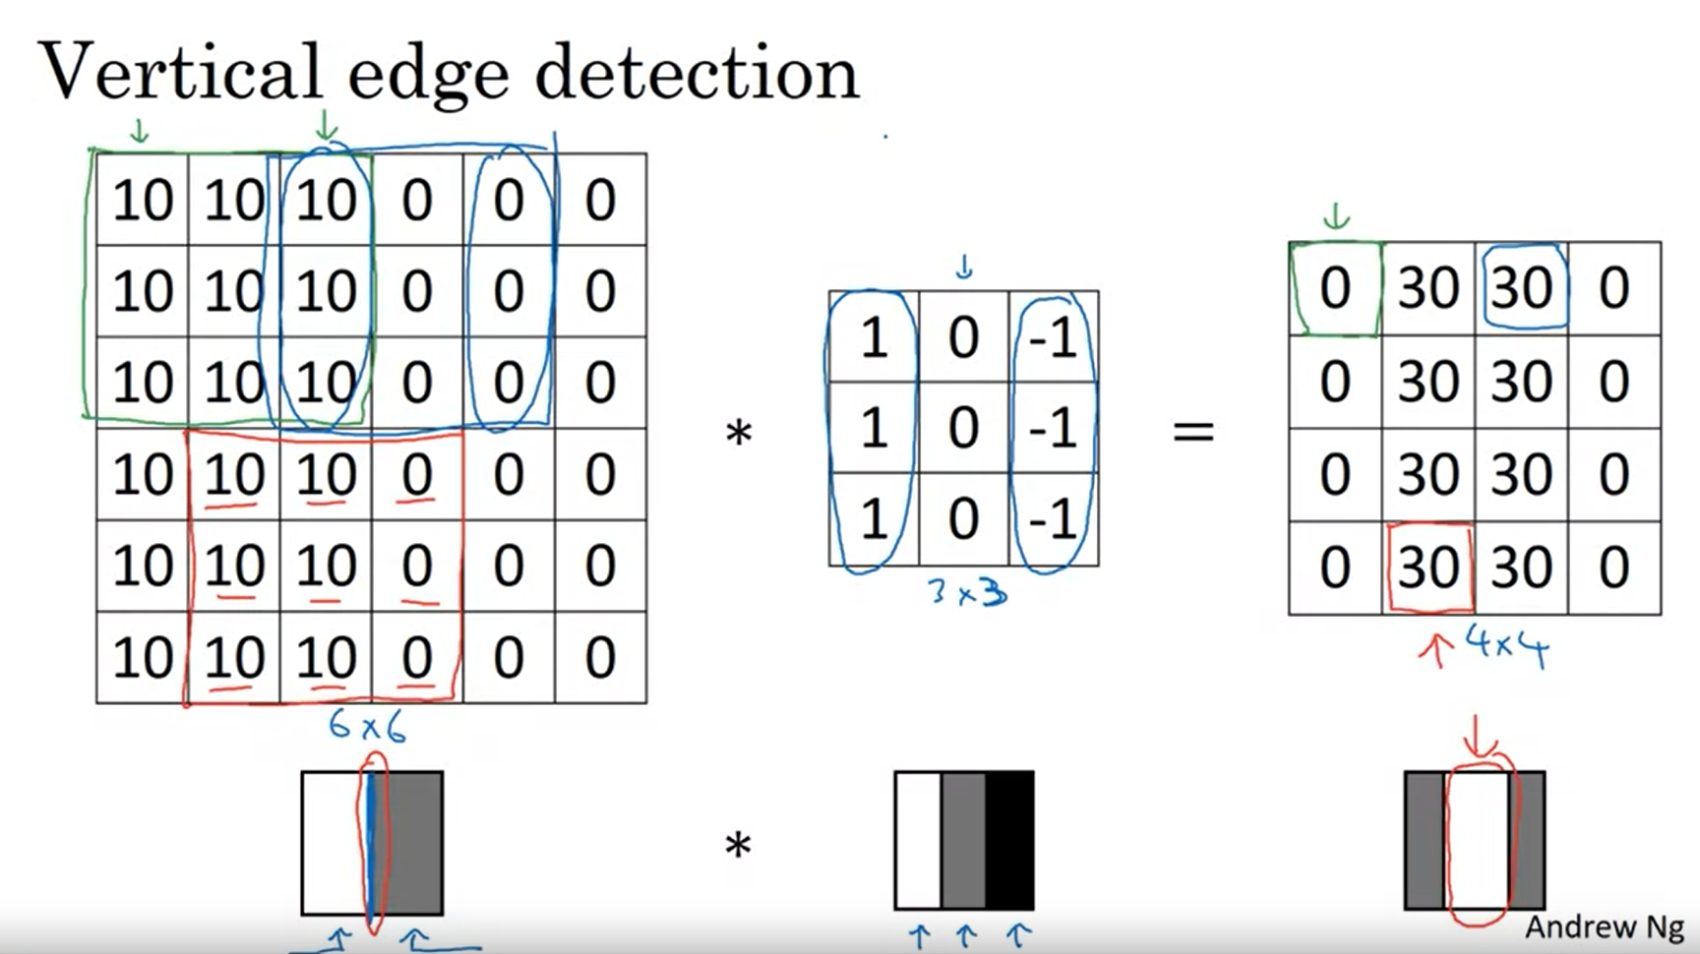

The detected edge only seems thick because we are working with small images. This would not be the case for big images (e.g. 1000x1000).

This is now a “handmade” convolutional edge detection filter.

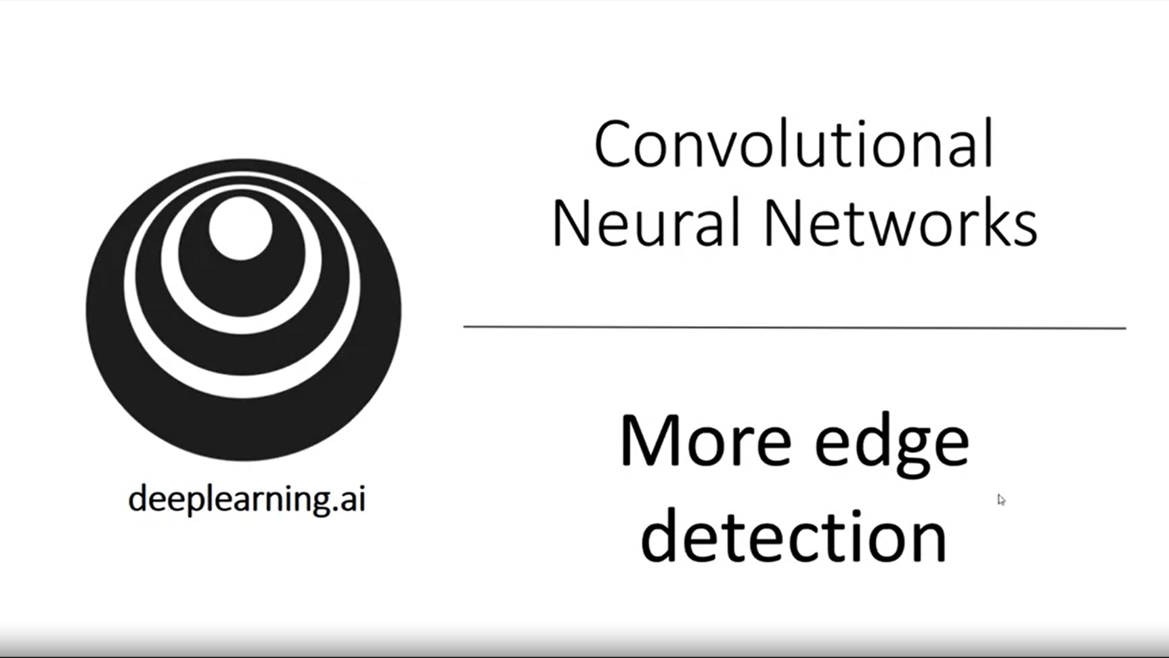

Difference betwen positive and negative edges.

How can an algorithm learn an edge detector instead of handcrafting it?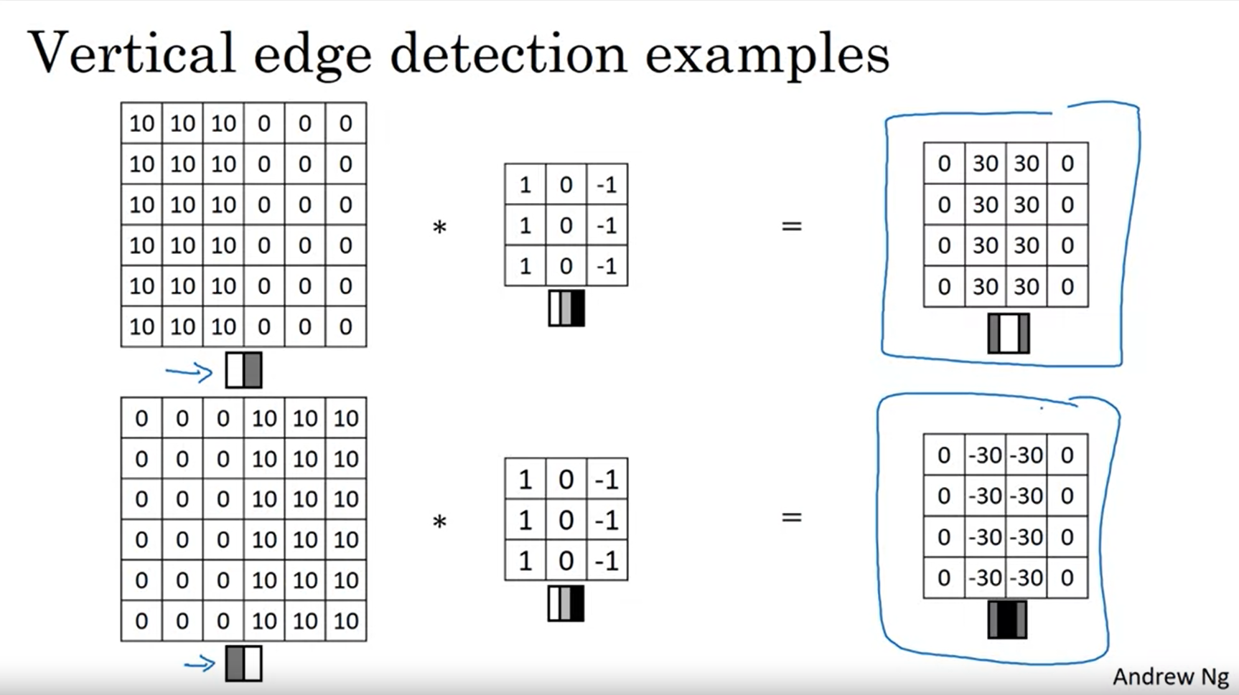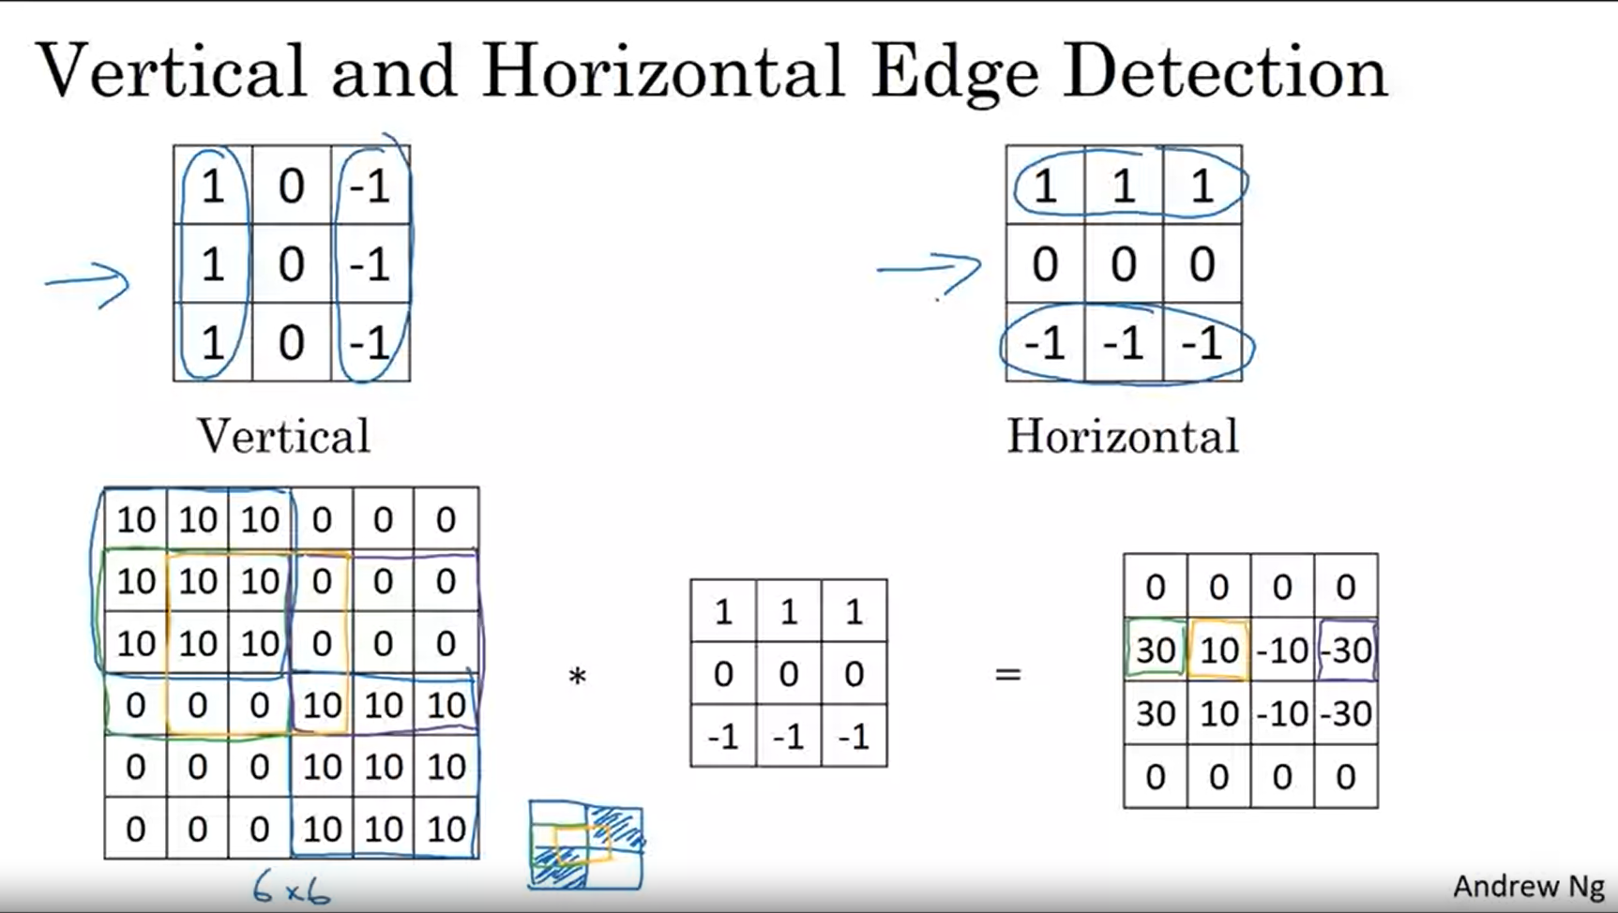

Horizontal edge: pixels are bright on the top and dark in the bottom row.

The intermediate values (10 and -10) are just an artifact of the small images we have here because it captures part of one edge and part of the other edge.

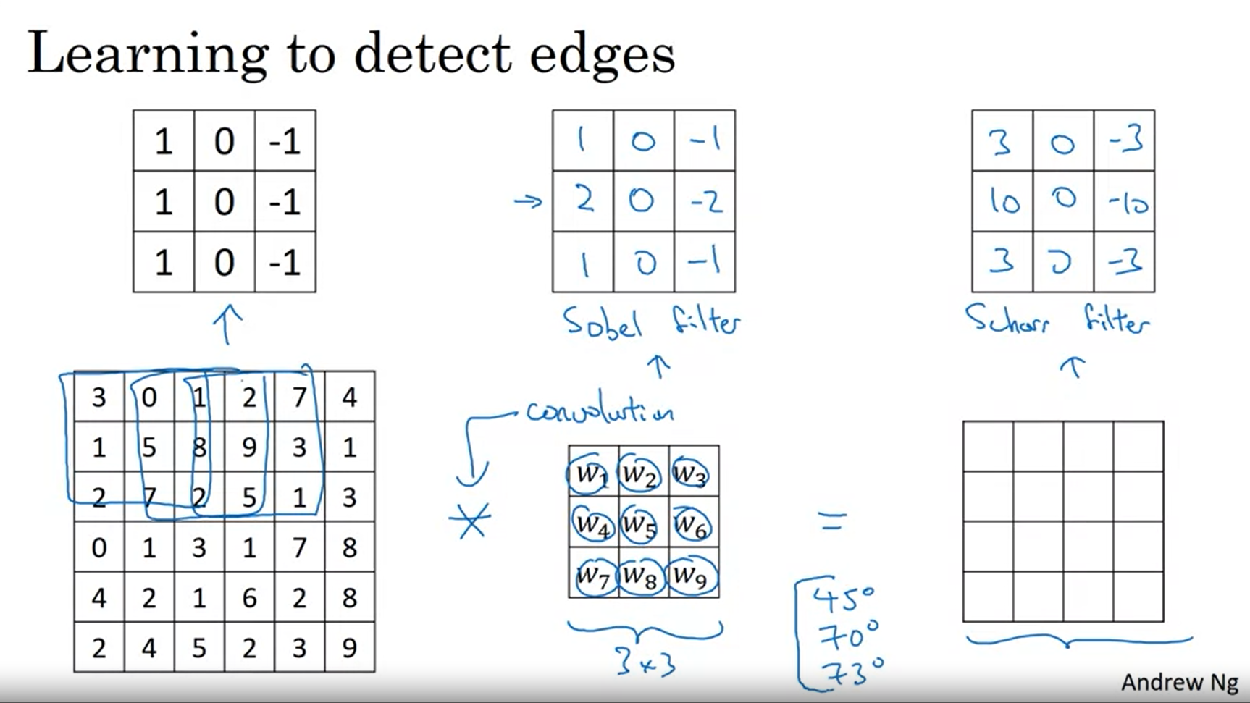

If you want to detect edges in a complicated image better not have computer vision researchers handpick the 9 numbers of the filter but let the network learn them using backpropagation. It can learn a better filter to capture the statistics of the data (more robustly) and reflect different angles for example. 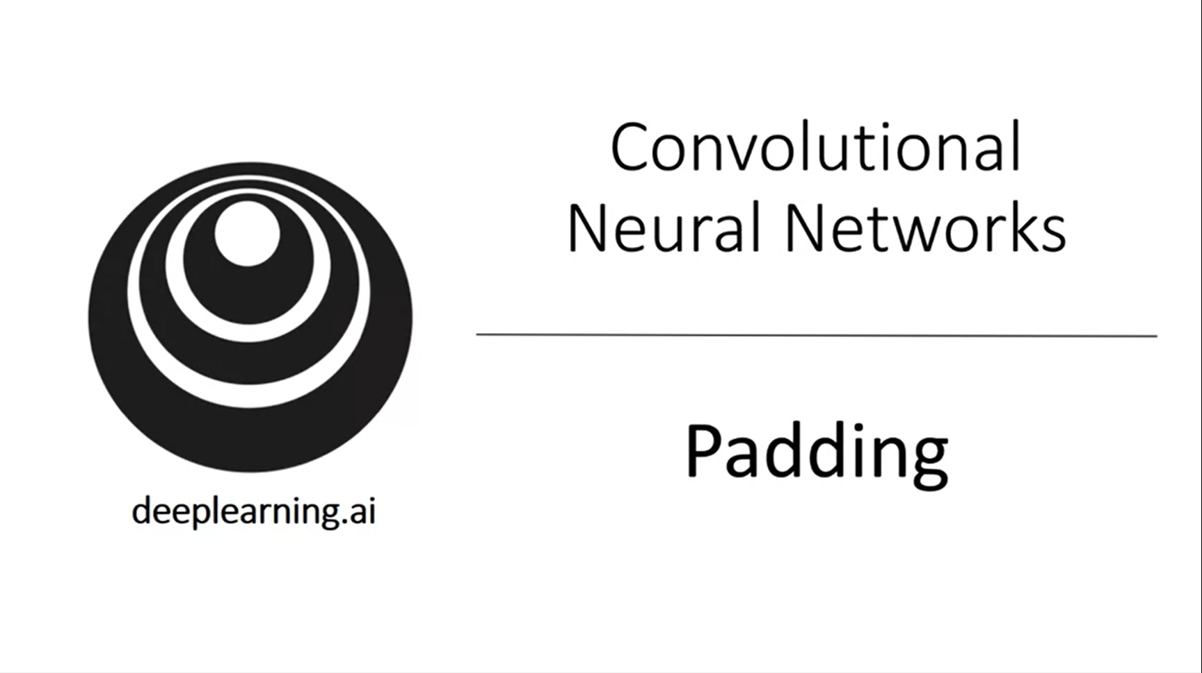

Let’s discuss some variations of the convolution operation.

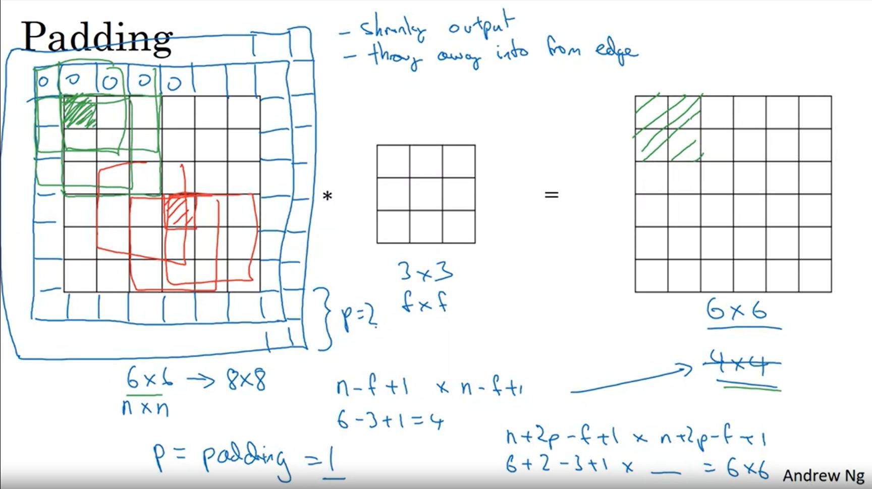

Without padding 6x6 image convolved with 3x3 filter results in 4x4 output -> disadvantage of this: image shrinks and you can only do that a couple of times. Also, pixels close to the edges of the image are used much less and you throw away information contained in these.

To solve both these problems (especially for deep neural nets) we introduce padding.

With a padding of 1 on each side we can preserve the original image size. Also we consider the edges more often.

There are two common padding choices (same, valid convolution)

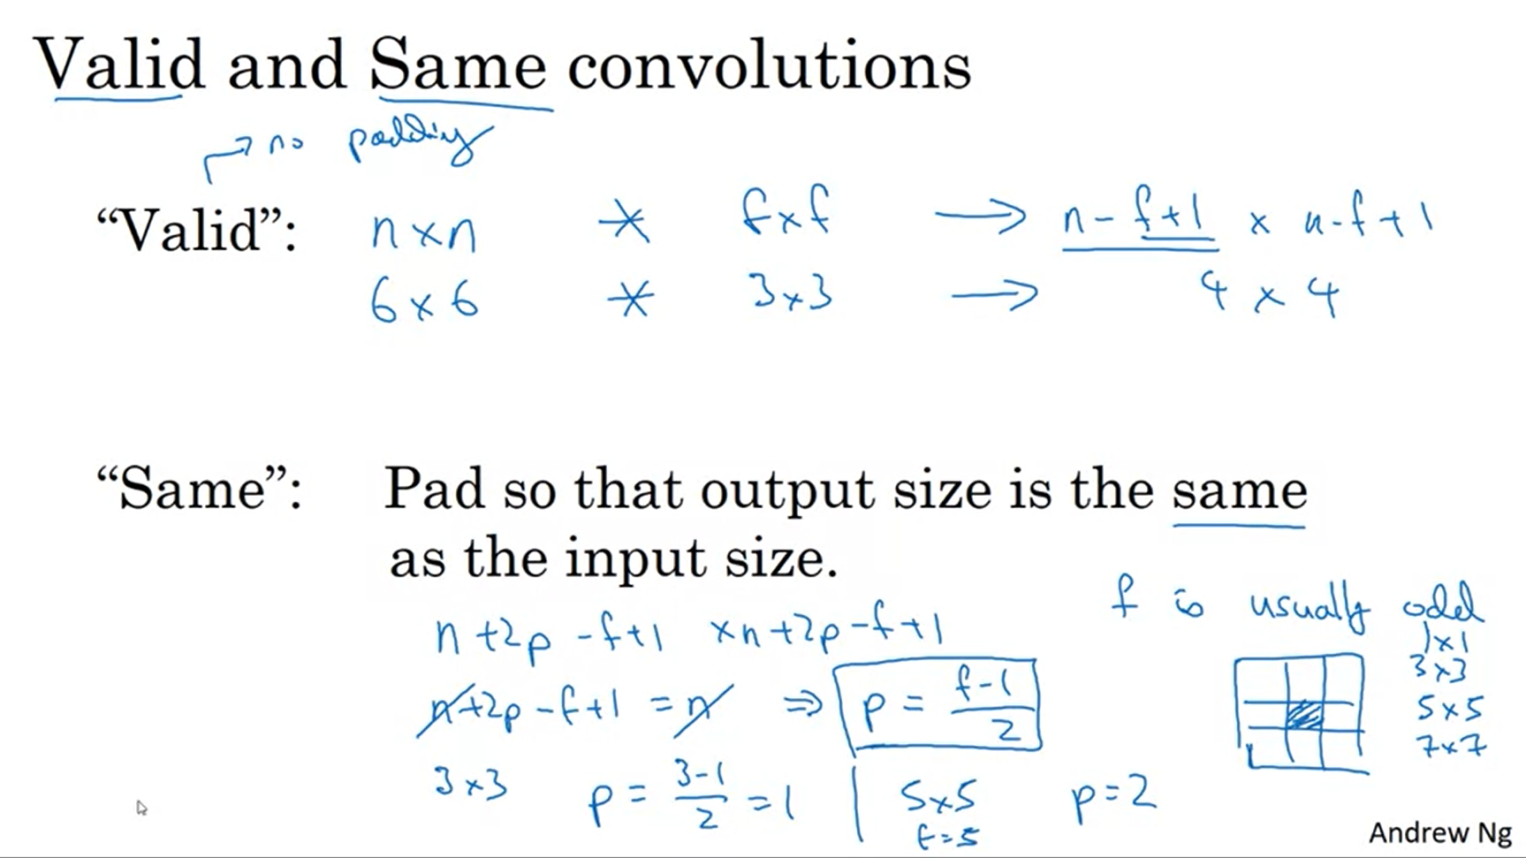

You rarely see even-numbered width filters in computer vision. Two reasons for that: asymmetric padding would be needed to get same convolution; second is an odd filter has a central position which can be nice.

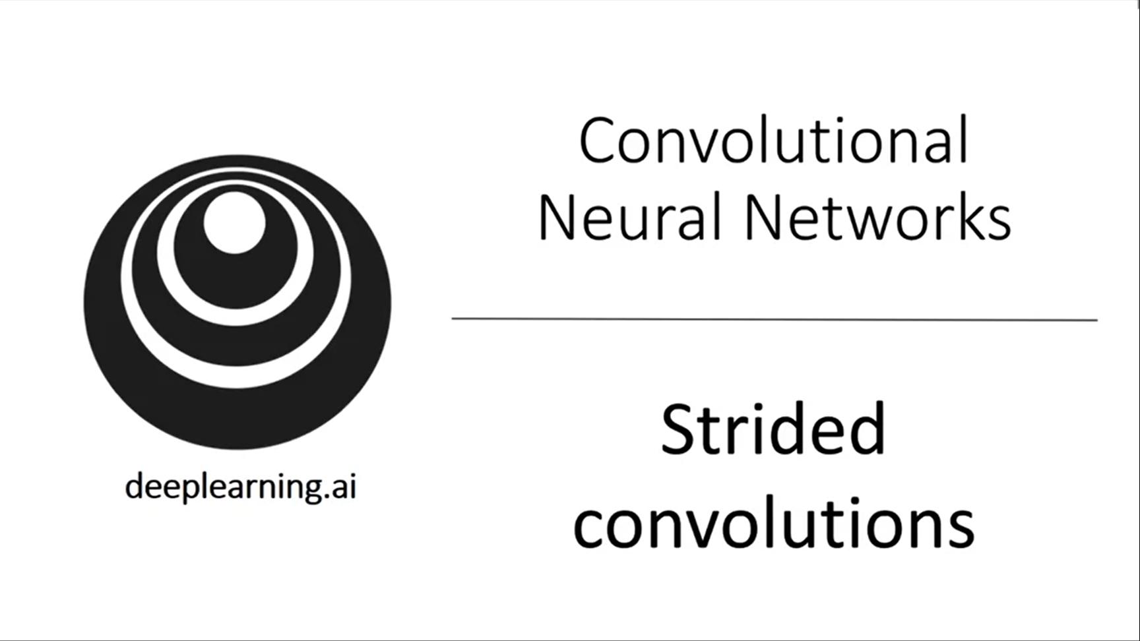

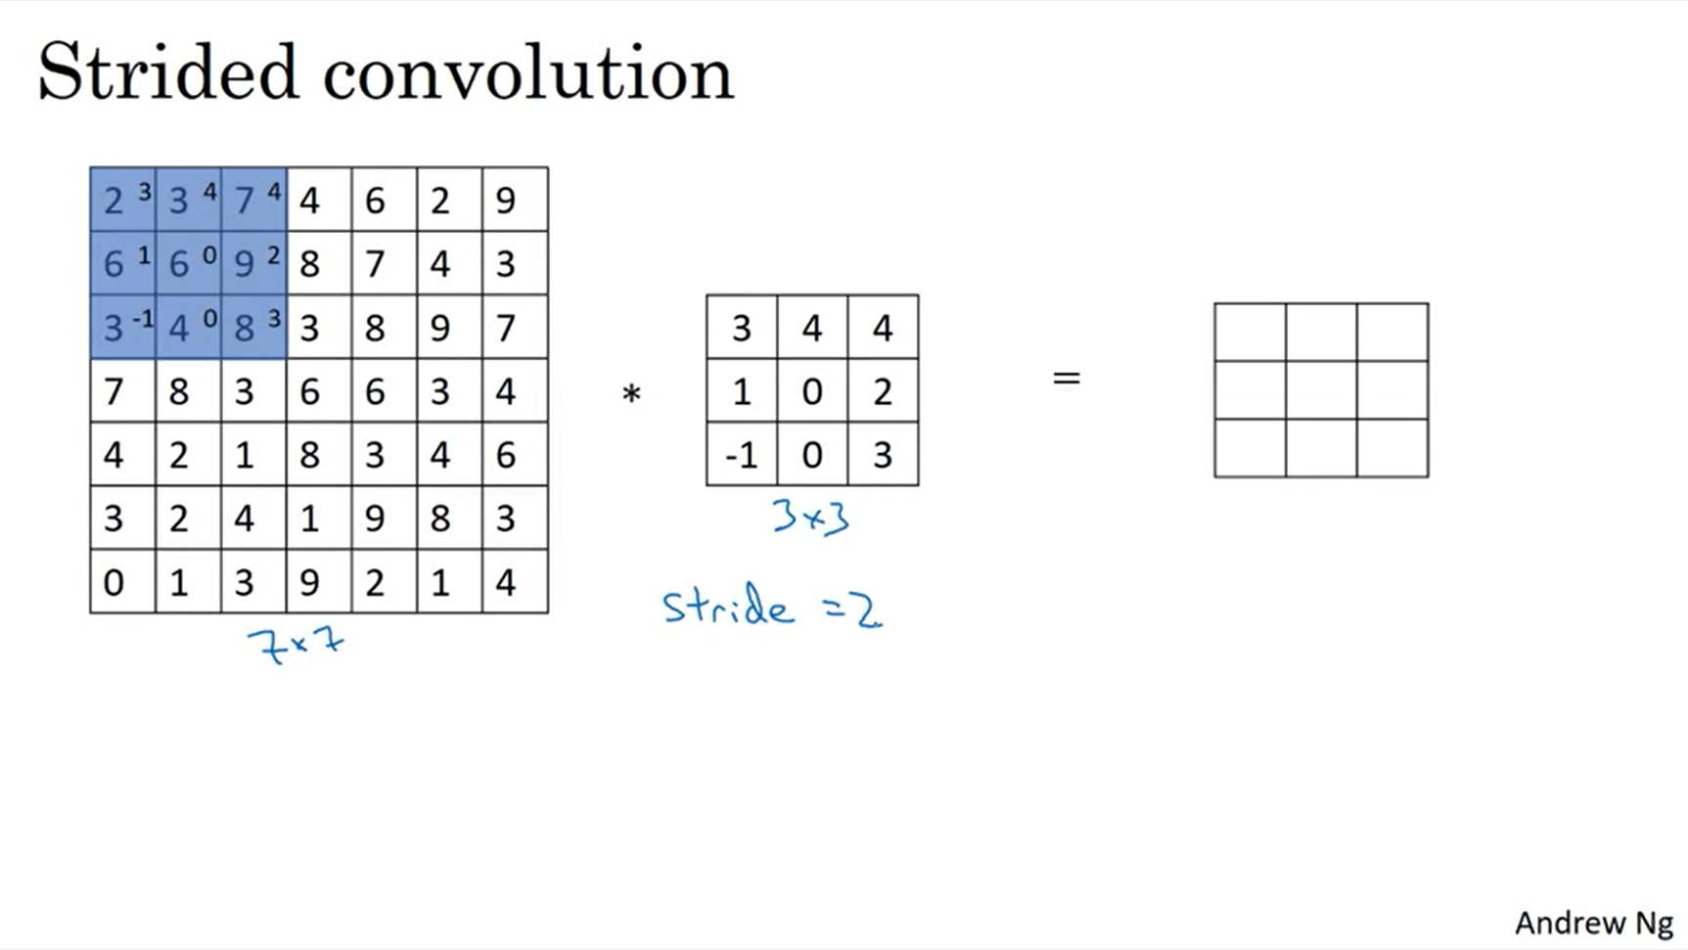

Step over the blue box by two steps.

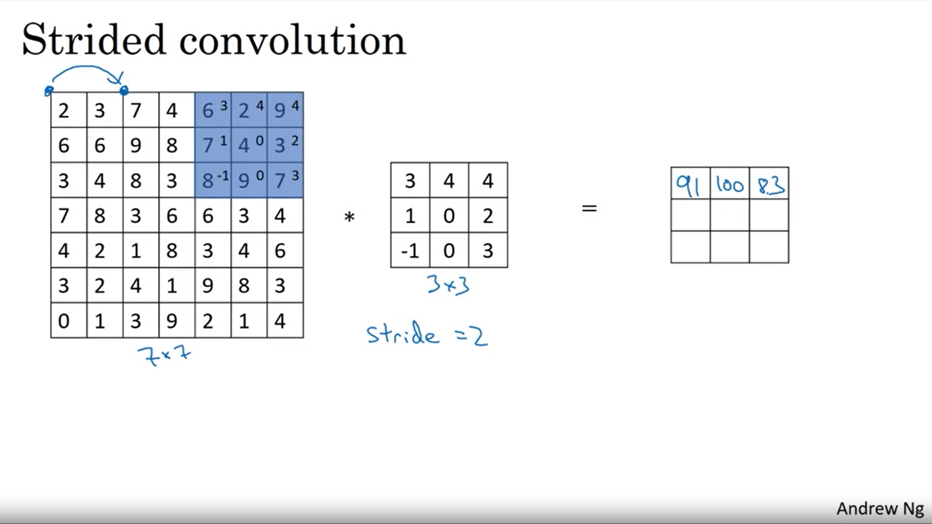

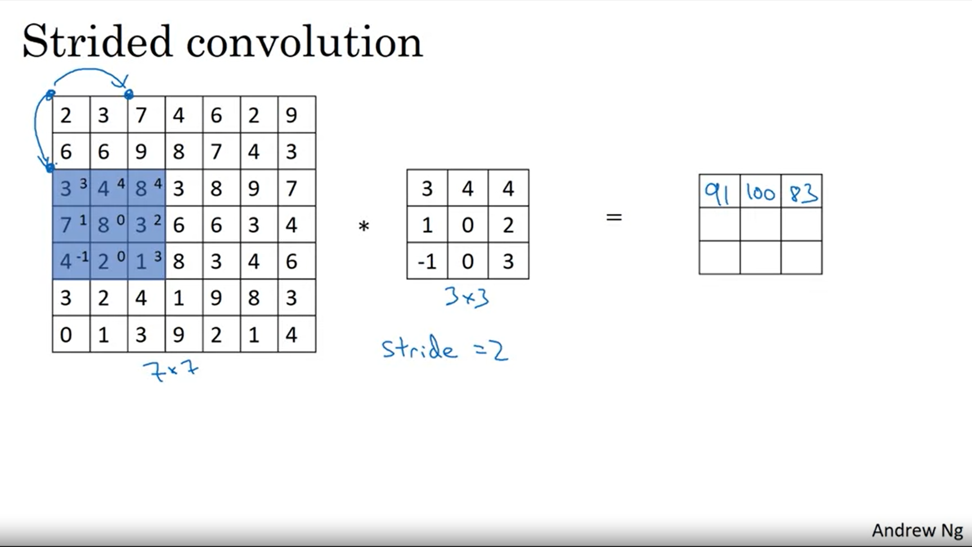

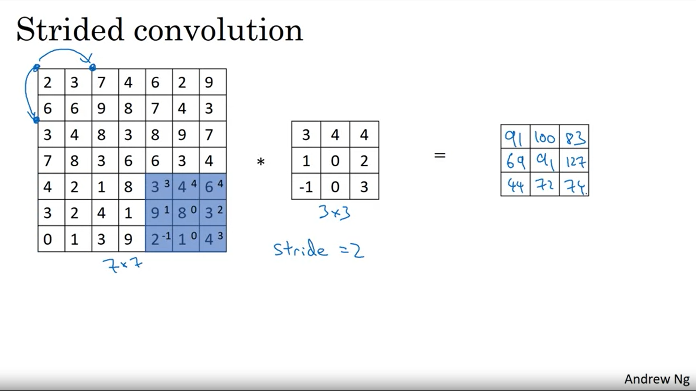

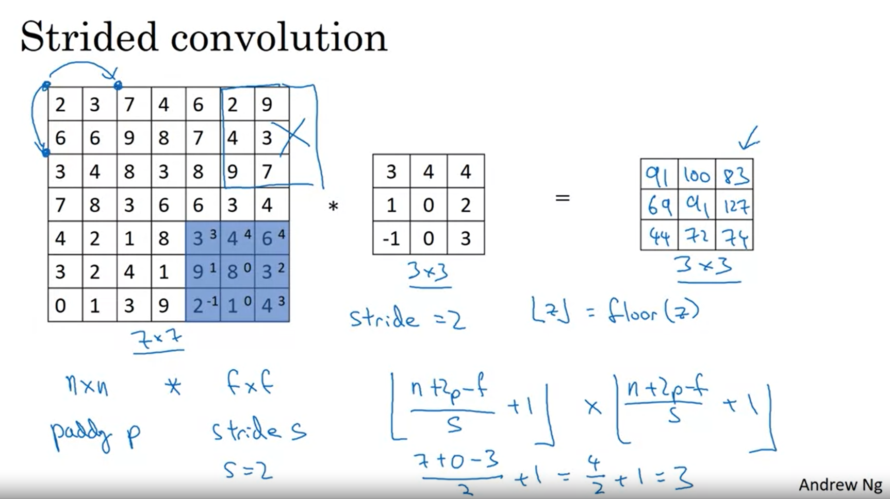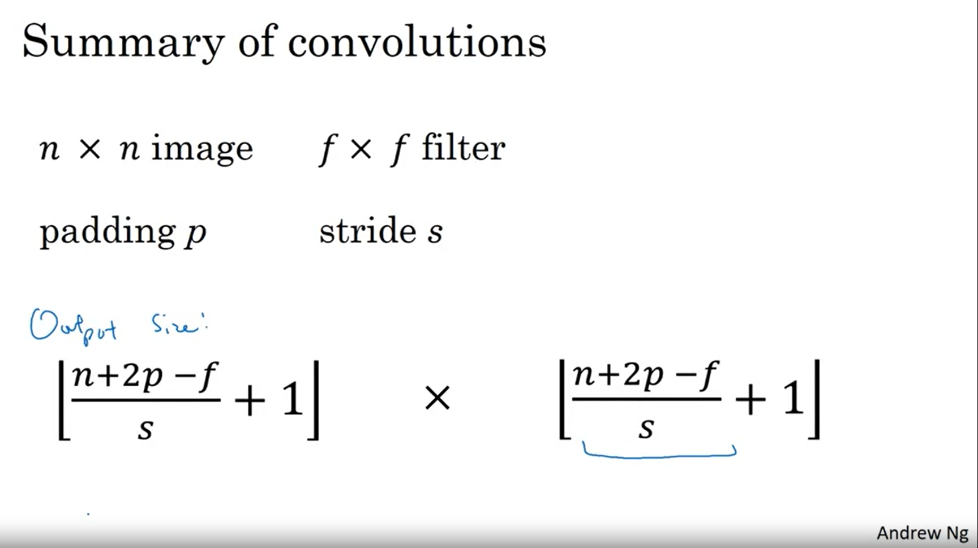

Square bracket notation indicates floor operation (round down).

In the math / signal processing context the convolution operation may include to flip the filter first. In these videos we have skipped the mirroring operation. Technically what we are actually doing is also called cross correlation. The deep learning literature just calls this the convolution operator (without bothering about the flips).

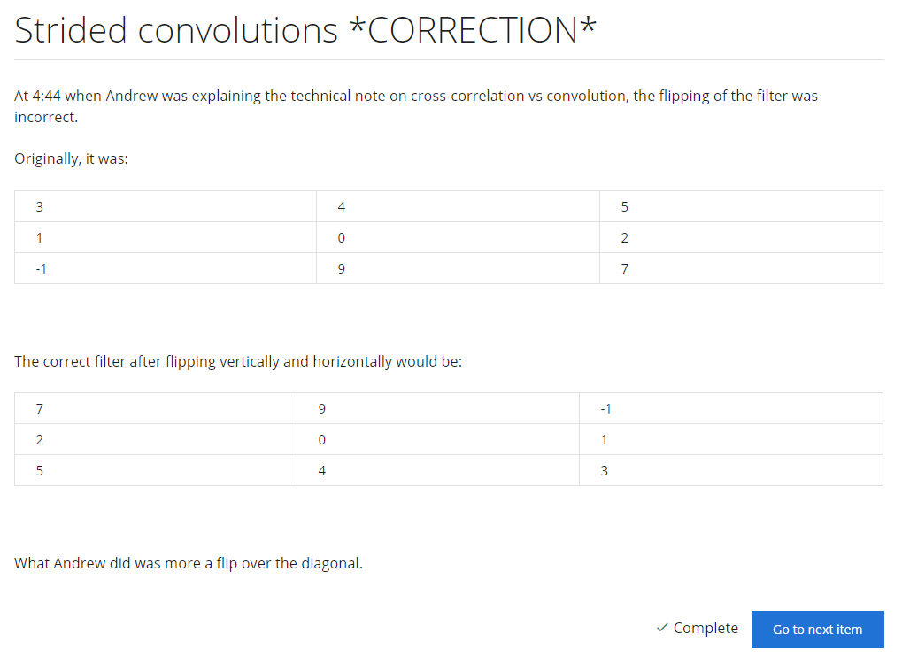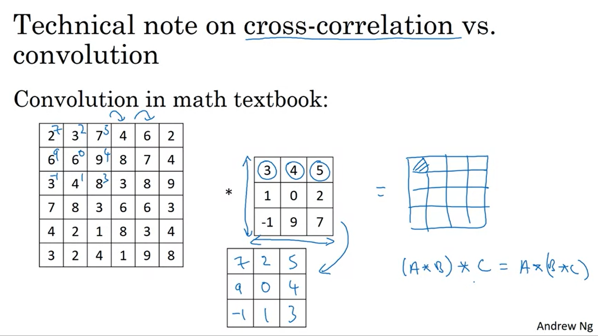

Associativity is given for the convolution operation with flipping. This is nice for some signal processing applications but is not relevant for deep learning.

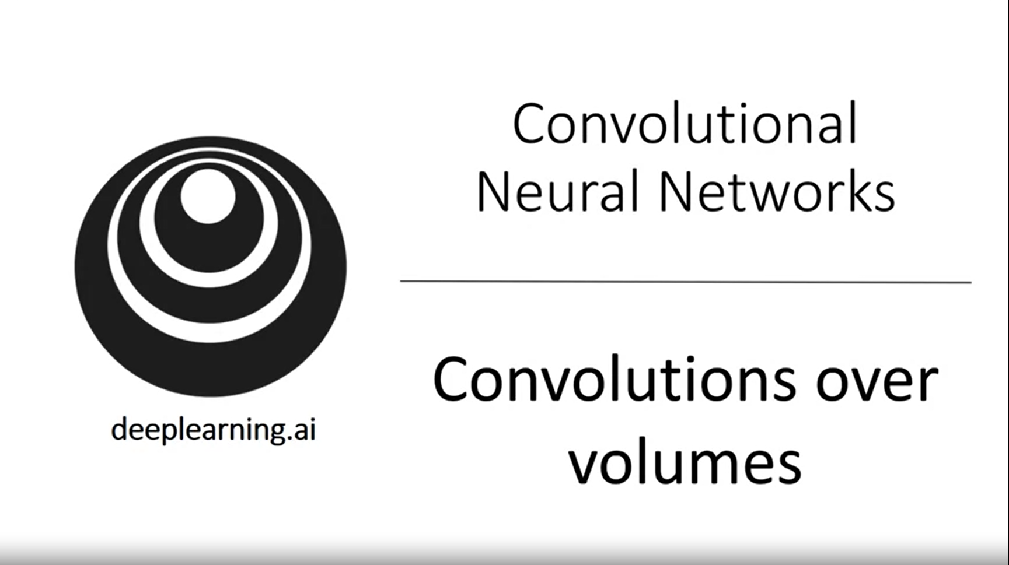

How to carry out convolutions over volumes instead of 2D matrices?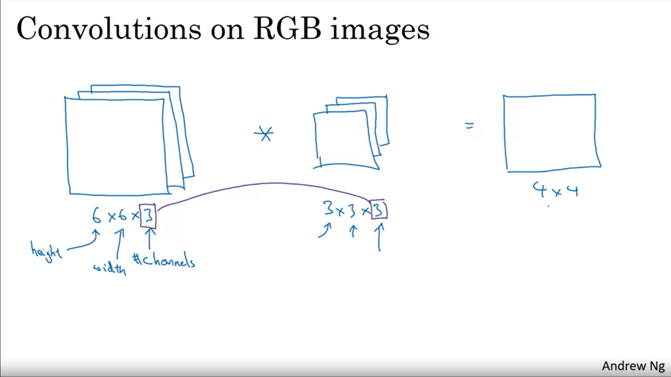

Detect features in a RGB image (stack 3 6x6 images).

The filter itself will also have 3 layers corresponding to the 3 channels.

The number of channels in the image must match the number of channels in the filter.

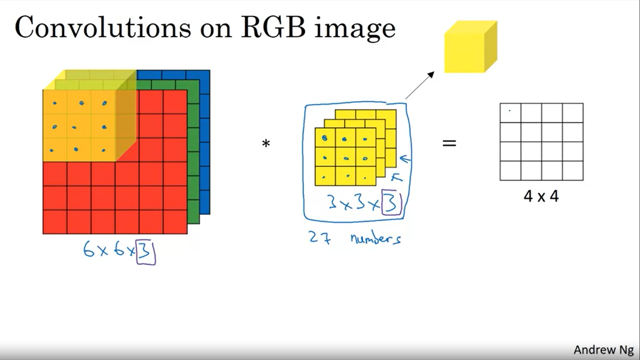

The filter is now a 3D cube.

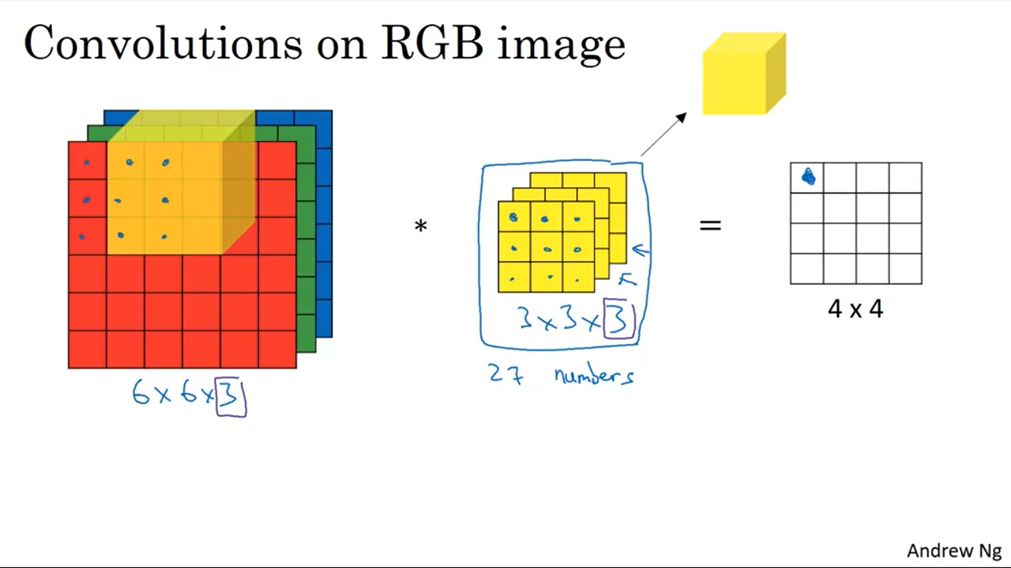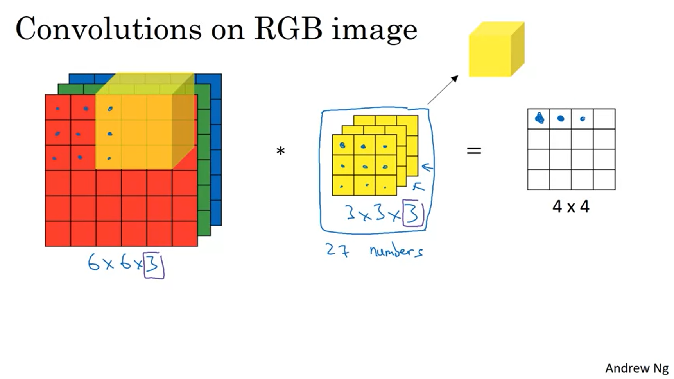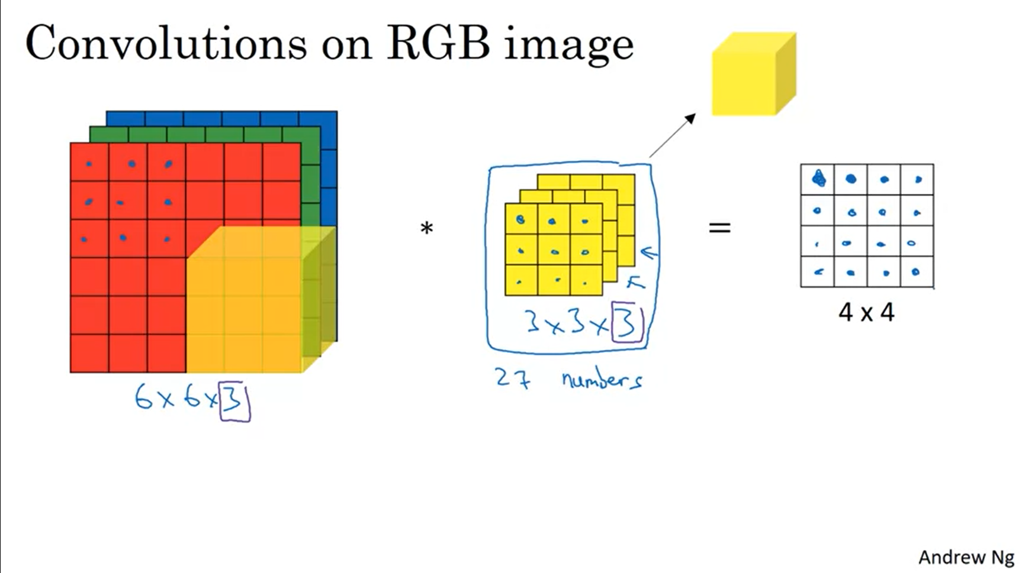

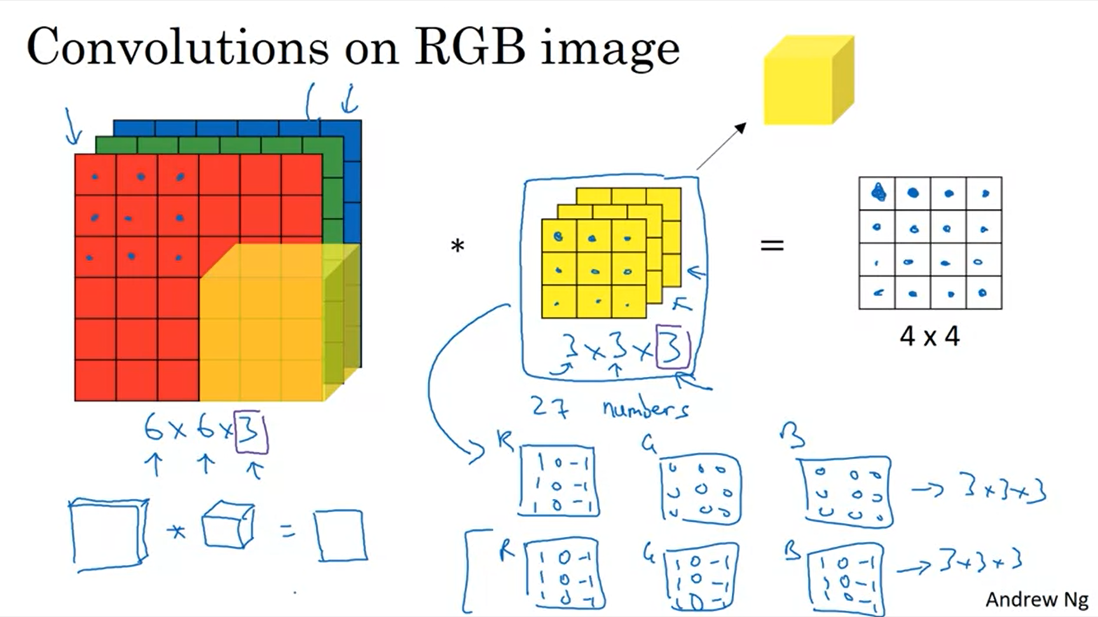

First example: detect edges in red channel only.

Second example: detect edges in all 3 channels.

The filter can have a different number for width and height but not for channels.

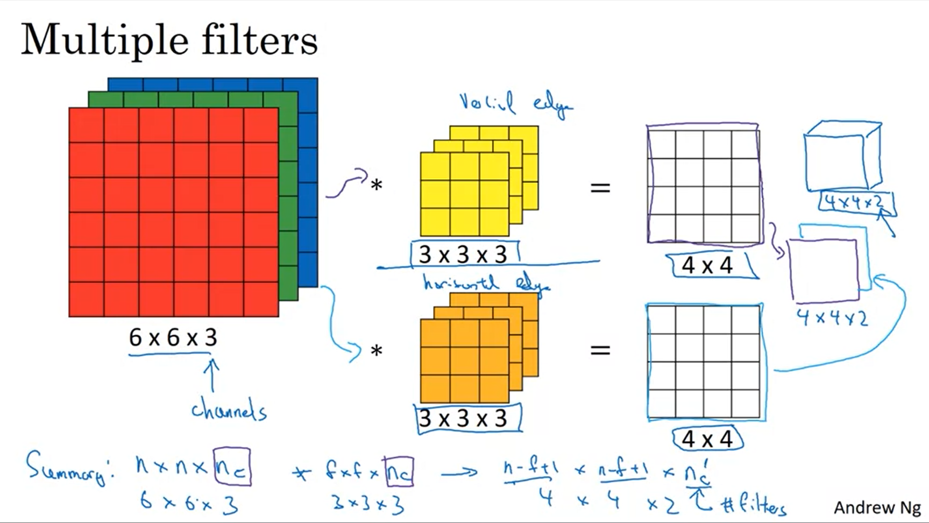

What if we want to detect, for example, multiple different edges at the same time? Multiple filters.

Example: apply 2 4x4 filters -> this will result in a 4x4x2 output volume. Here we assume no padding and stride of 1.

Now we can detect multiple different features.

Number of channels = depth (in literature).

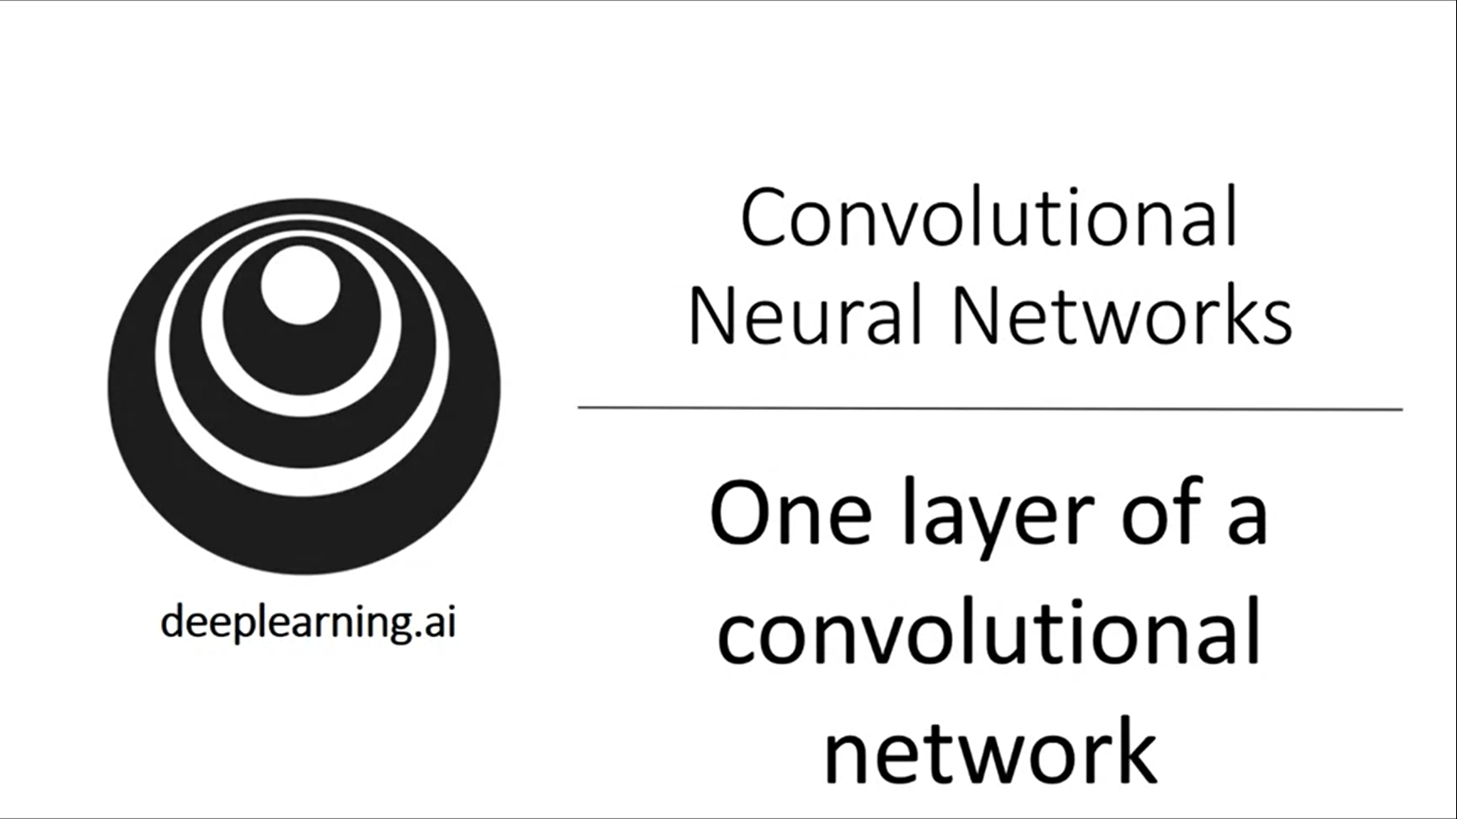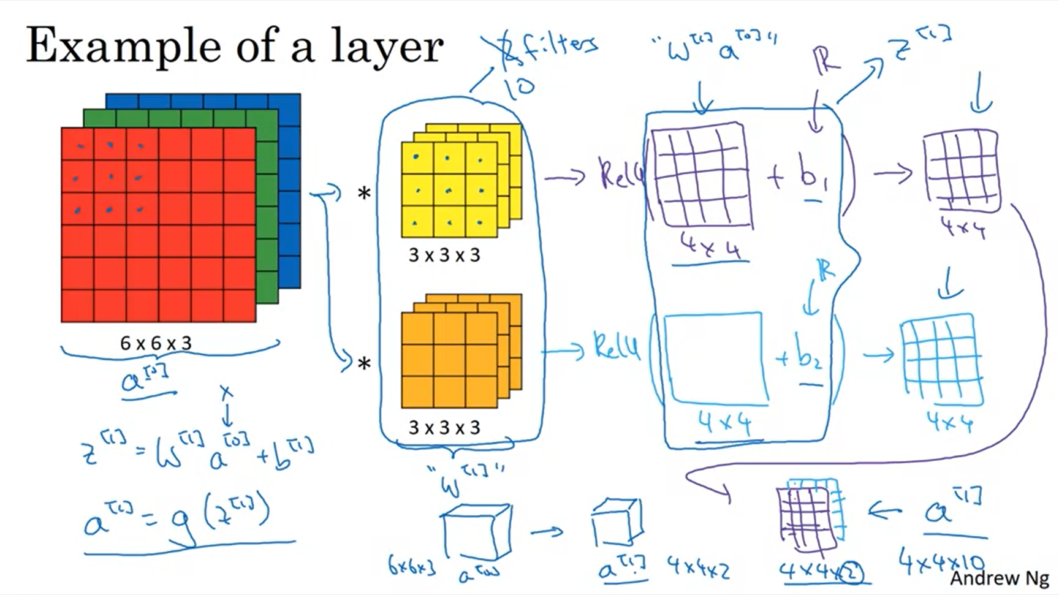

To convert what we have so far into a convolutional neural net layer we add a bias (using Python broadcasting) and apply a non-linearity (here ReLu).

Analogy to fully connected neural net. First with 2 filters, then with 10 filters.

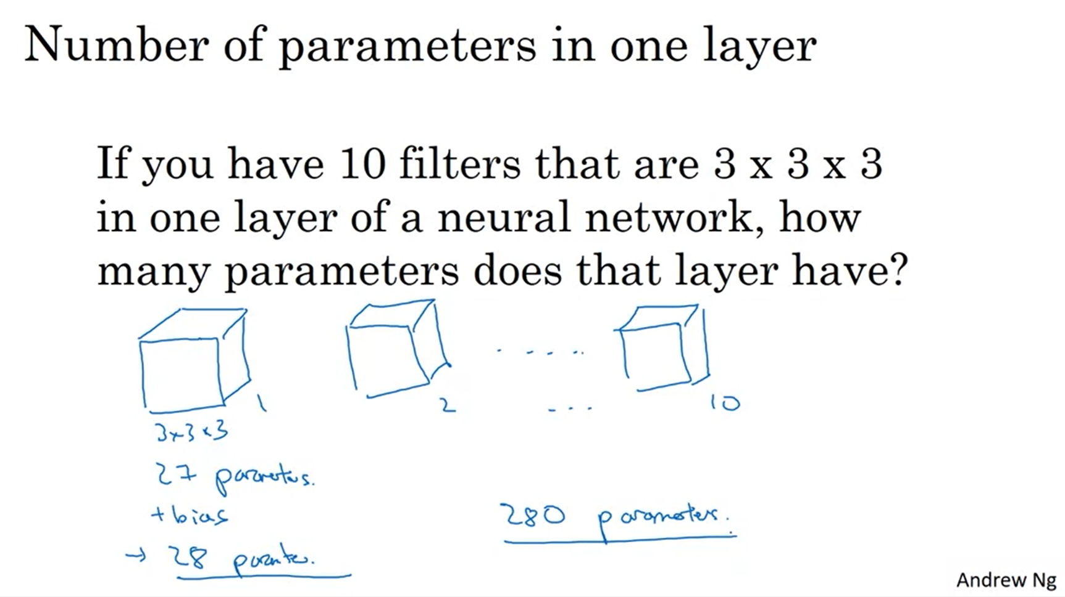

Notice that this is independent of the input image size. This is quite nice. The parameters are shared across the regions of the input image. This makes them less prone to overfitting.

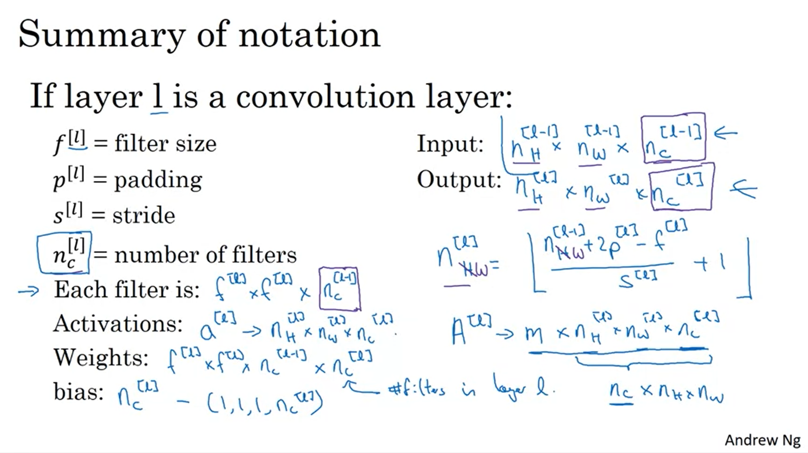

There is no real convention for the ordering of height, width, number of channels. This can be different from open source repo to open source repo (unfortunately no consensus).

The key takeaway here is how one convolutional layer works.

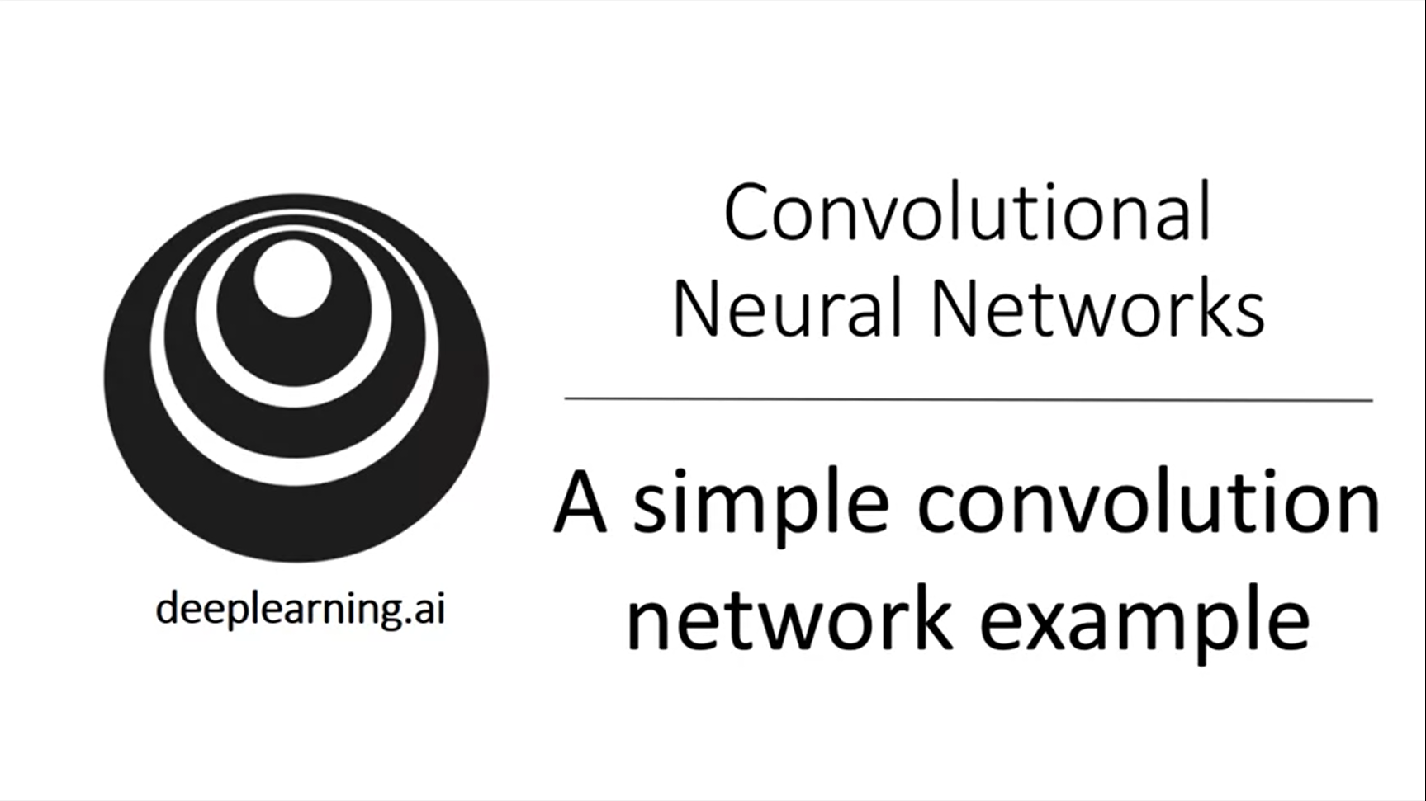

Let’s go through a concrete example of a deep neural conv net.

Example: cat classification with 39x39x3 images

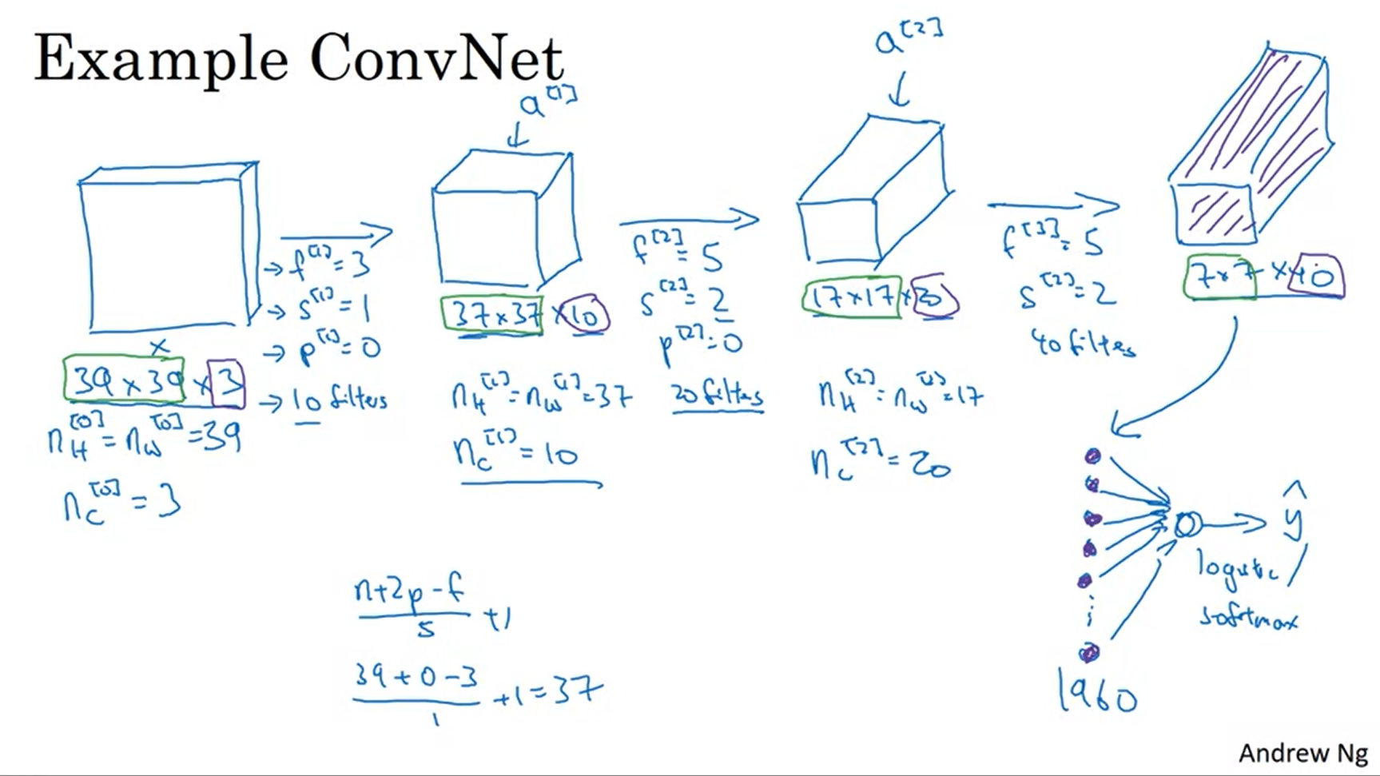

First layer: 10 filters -> next layer has 10 channels. Valid convolution (no padding).

Next layer: use stride of 2 and 20 filters -> output will be 17x17x20. And so on.

Finally what is commonly done is flatten the volume into a vector of units and feed this to a logistic regression or softmax unit.

A lot of the work done in context with convnets is picking hyperparameters (filter amount, stride, padding etc.).

Also, usually height and width will shrink from beginning to end whereas the number of channels increases.

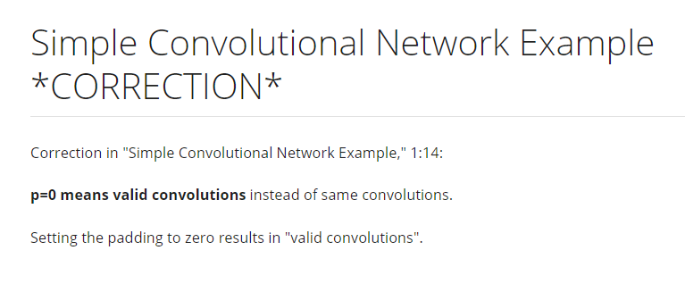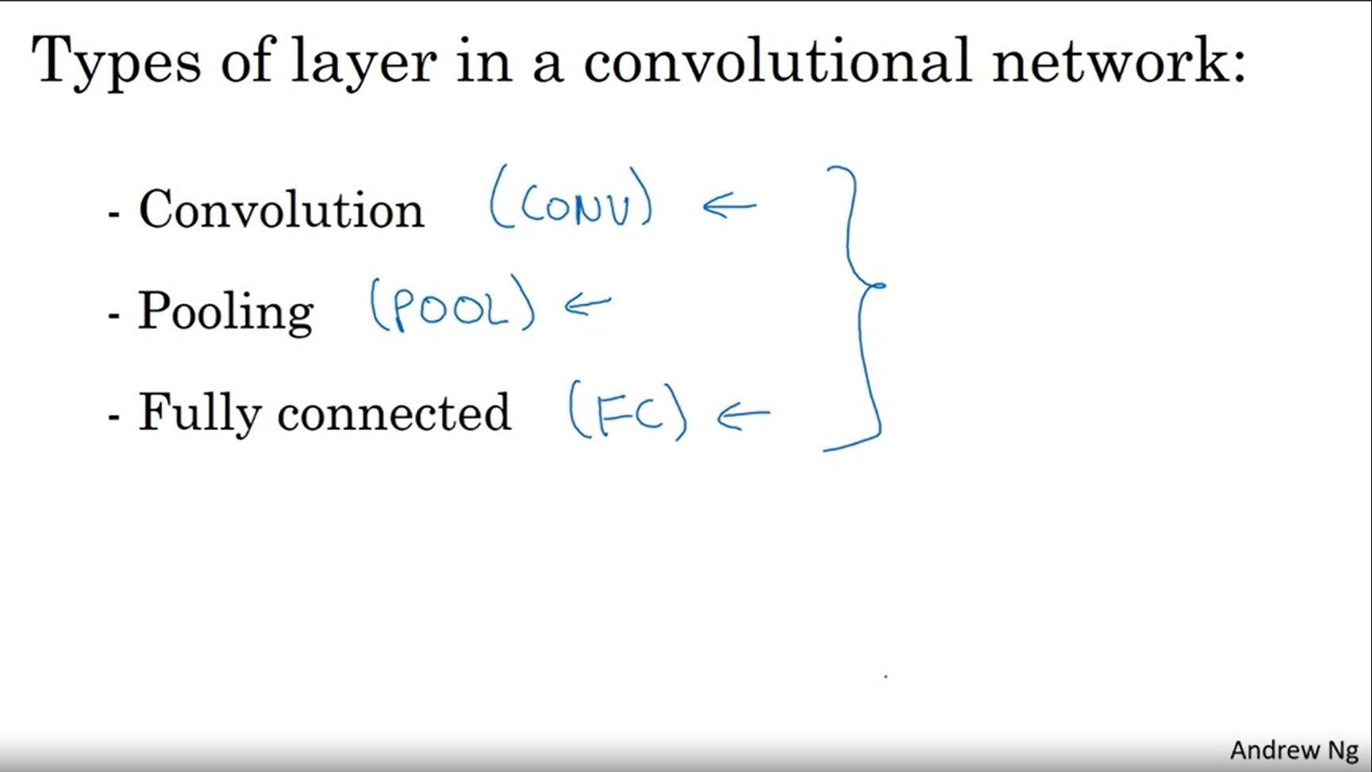

In a typical convnet there are 3 types of layers. Most neural network architectures will mix these and not only have convolutional layers.

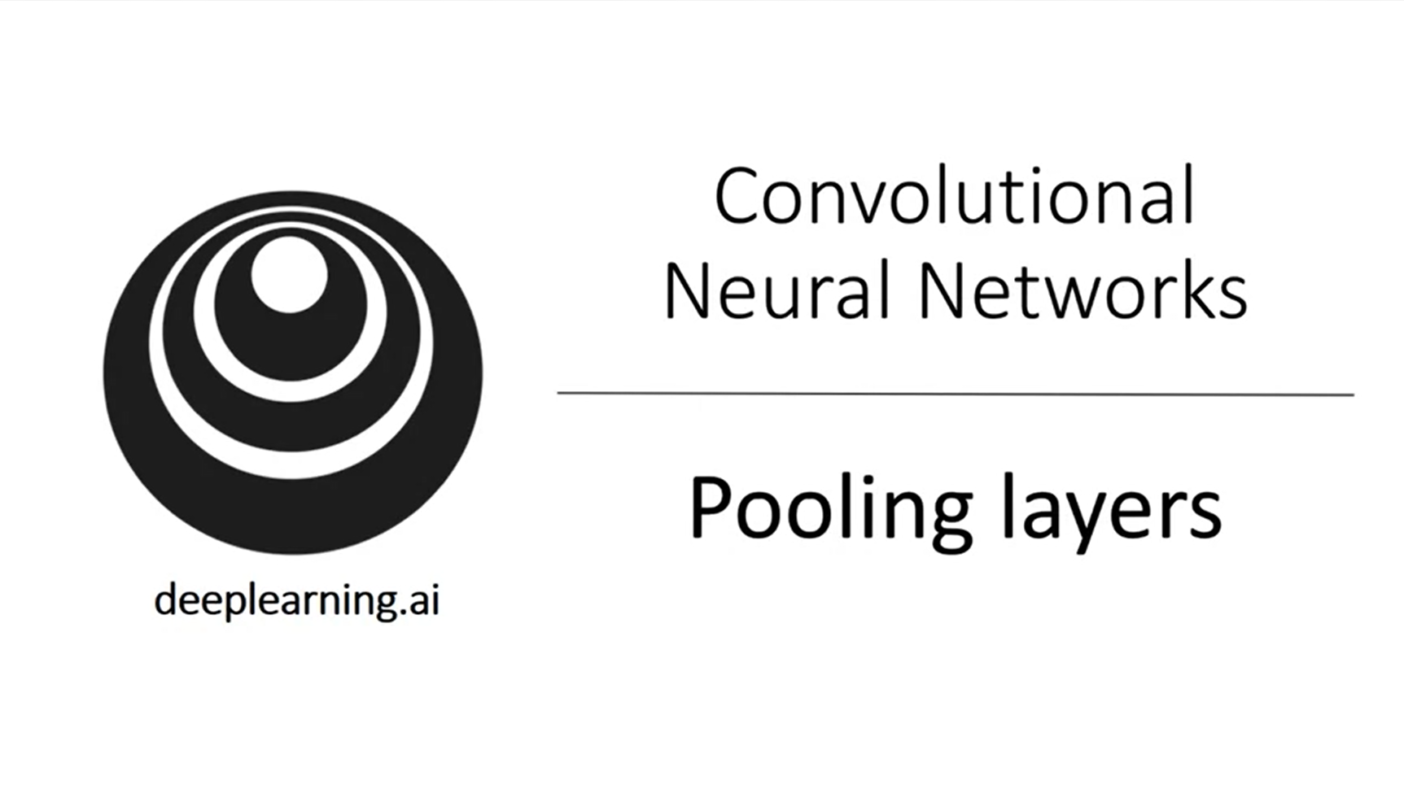

Another type of layer is the pooling layer. This can be used to reduce the size of a volume to speed up computation as well as to make the features it detects more robust.

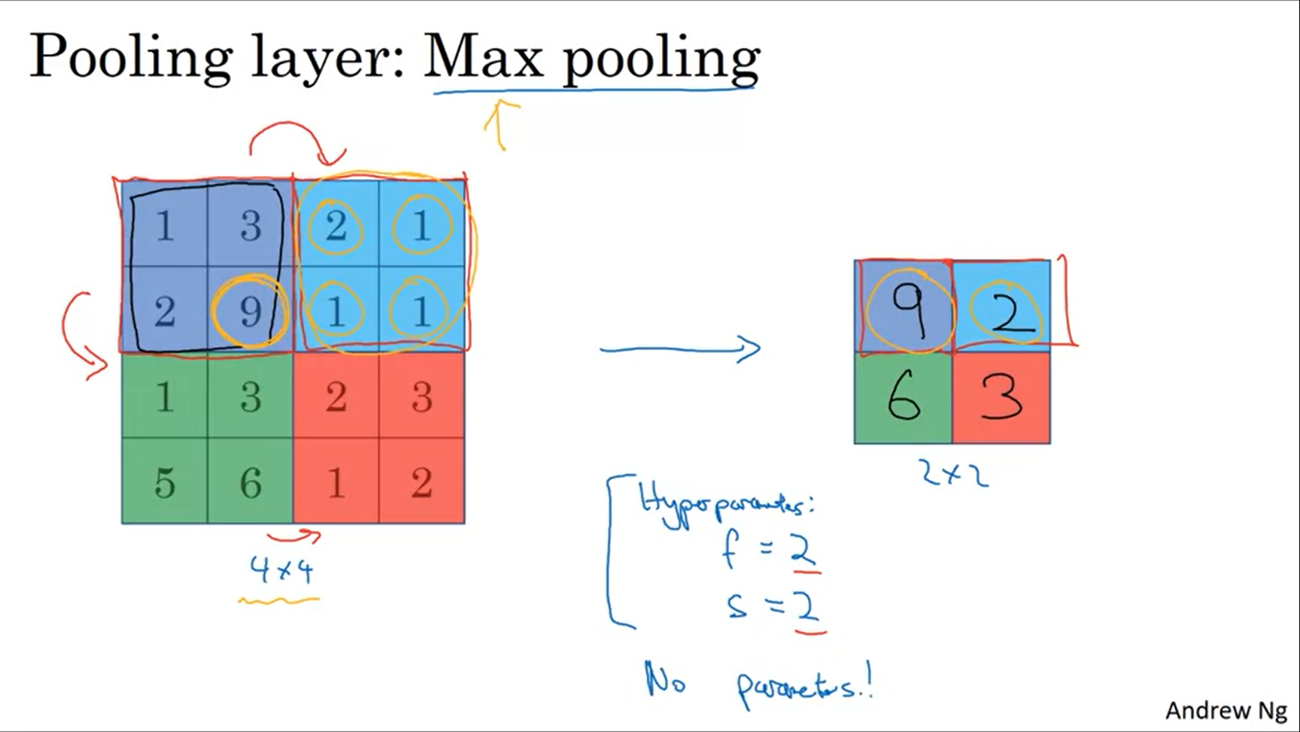

High value is a certain feature. Max pooling will keep that feature for the part where it appeared. If the feature does not exist, the max will also have a small value.

The main reason why people use max pooling is that it works well in experiments. Nobody can really confirm what is the underlying reason.

There is nothing for gradient descent to learn.

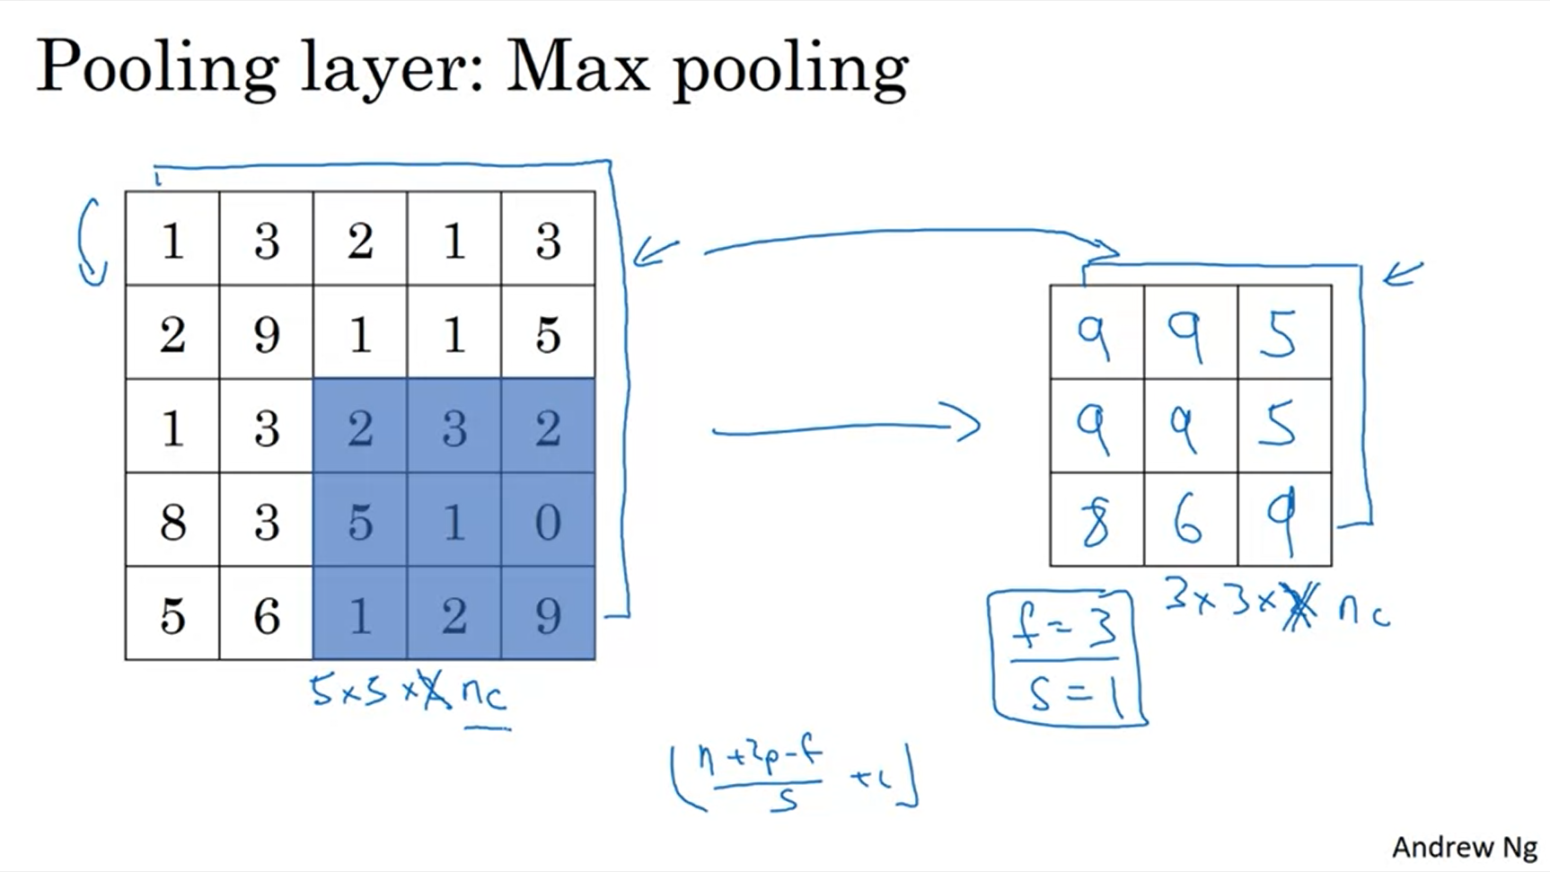

The same formula works for figuring out the output size of max pooling.

Here we have a stride of 1.

On a 3D input, the output will have the same dimension. The computation is performed on each of the channels independently.

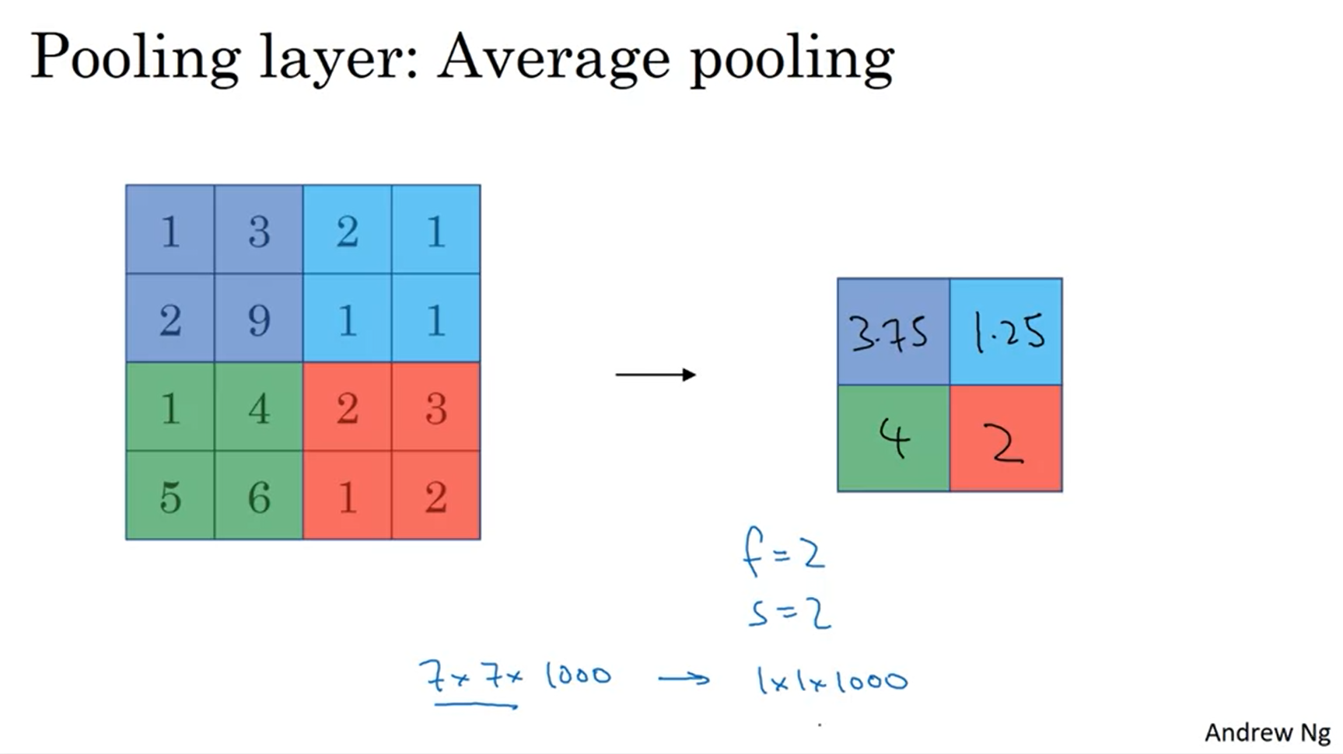

Average pooling is not used that often. One exception could be very deep in the neural network to just collapse the representation. Max pooling is used much more often.

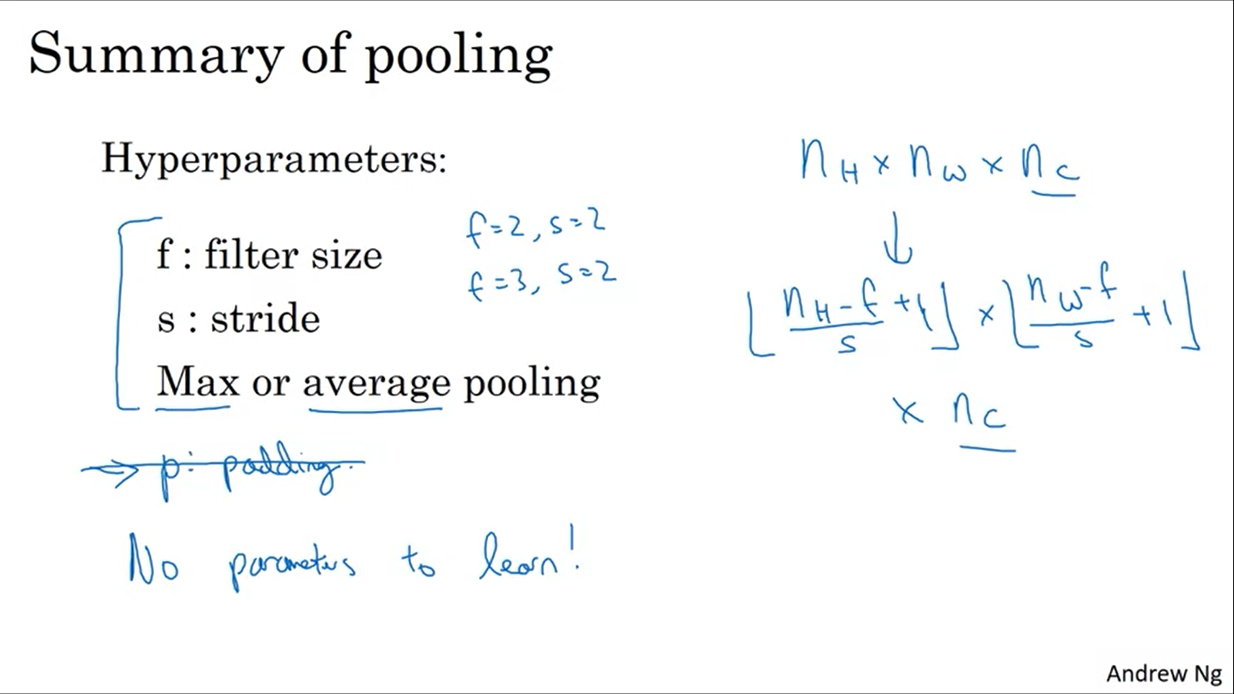

These are common choices for the hyperparameters (this has the effect to shrink the representation in terms of width and height by a factor of 2). Padding is almost never used for max pooling.

Backprop will adapt nothing here. There are only the hyperparameters that are set by the developer.

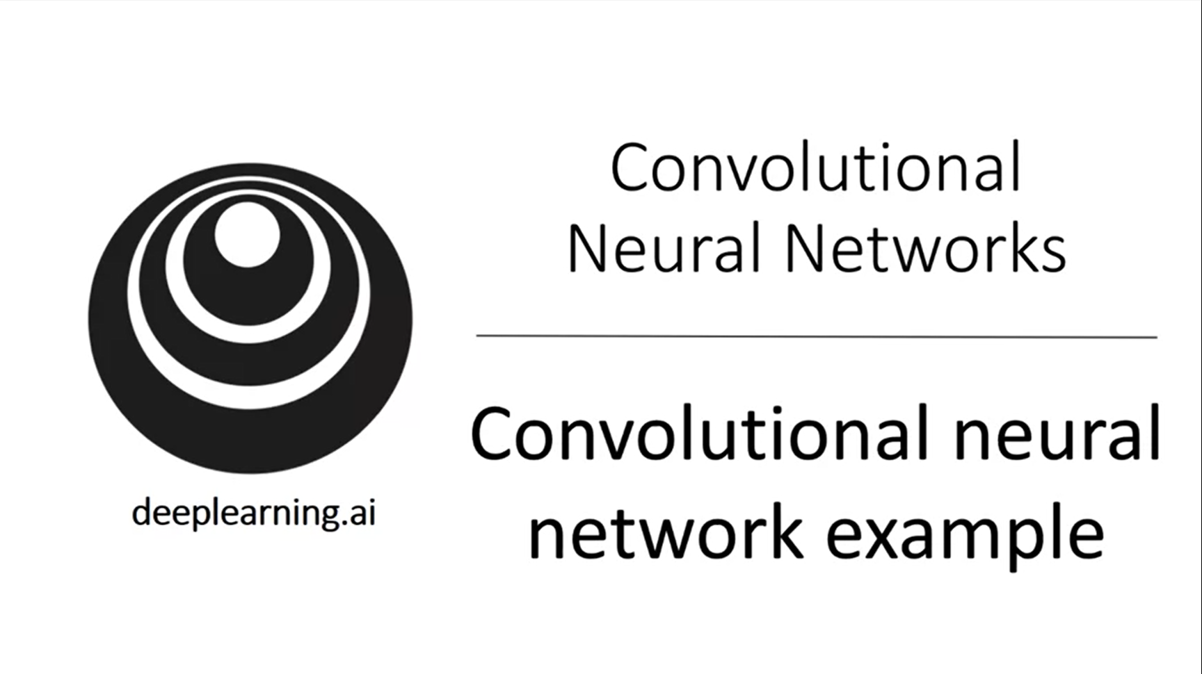

Let’s look at a more complex example of a convnet now that we know all the building blocks.

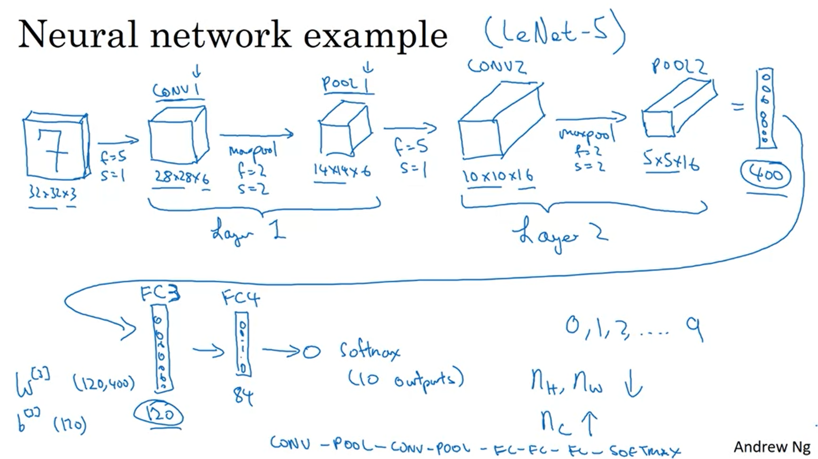

This network is inspired by LeNet-5 which was created quite some time ago by Yann LeCun.

There are ReLUs in the conv layers.

There are different conventions regarding layers. Usually only layers with parameters are reported as layers, so that conv and pool are summarized to one layer. Sometimes people deviate from this convention.

The 1 at the end of Conv 1 and Pool 1 refers to the layer.

After layer 2 flattening is applied, then the first fully connected layer follows (this is just like a vanilla network).

There are a lot of hyperparameters. One guideline is to use the literature as orientation to choose an architecture that has worked for someone else.

The layers as described here in their sequence are a common pattern that you see in neural nets.

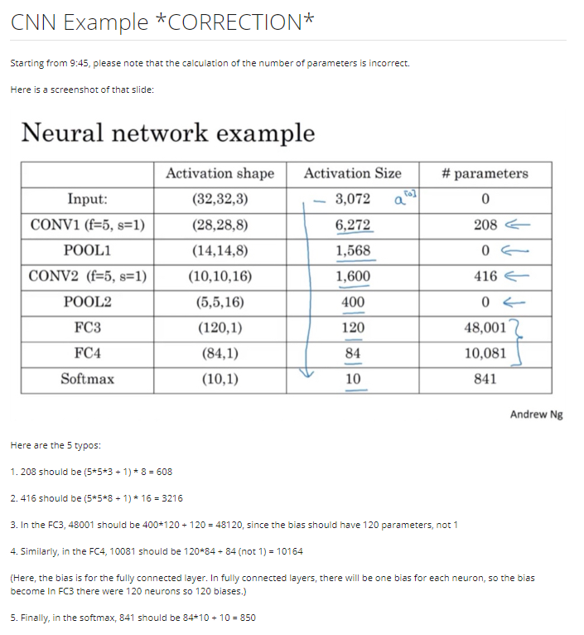

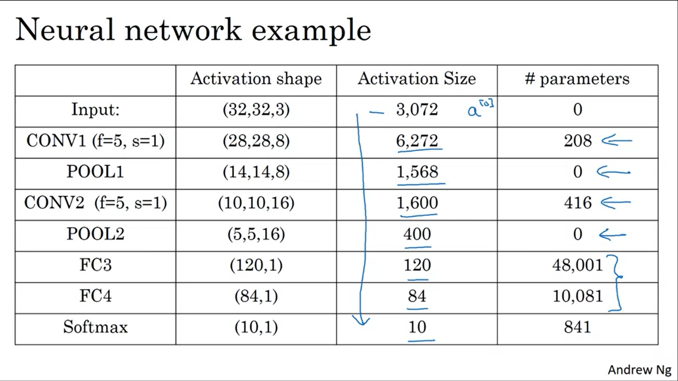

Conv layers have very few parameters compared to fully connected layers. The activation size goes down gradually as you go deeper into the neural net. If it goes down too quickly that is usually not great for performance as well.

Computer vision researchers try to put these building blocks together so that it works well.

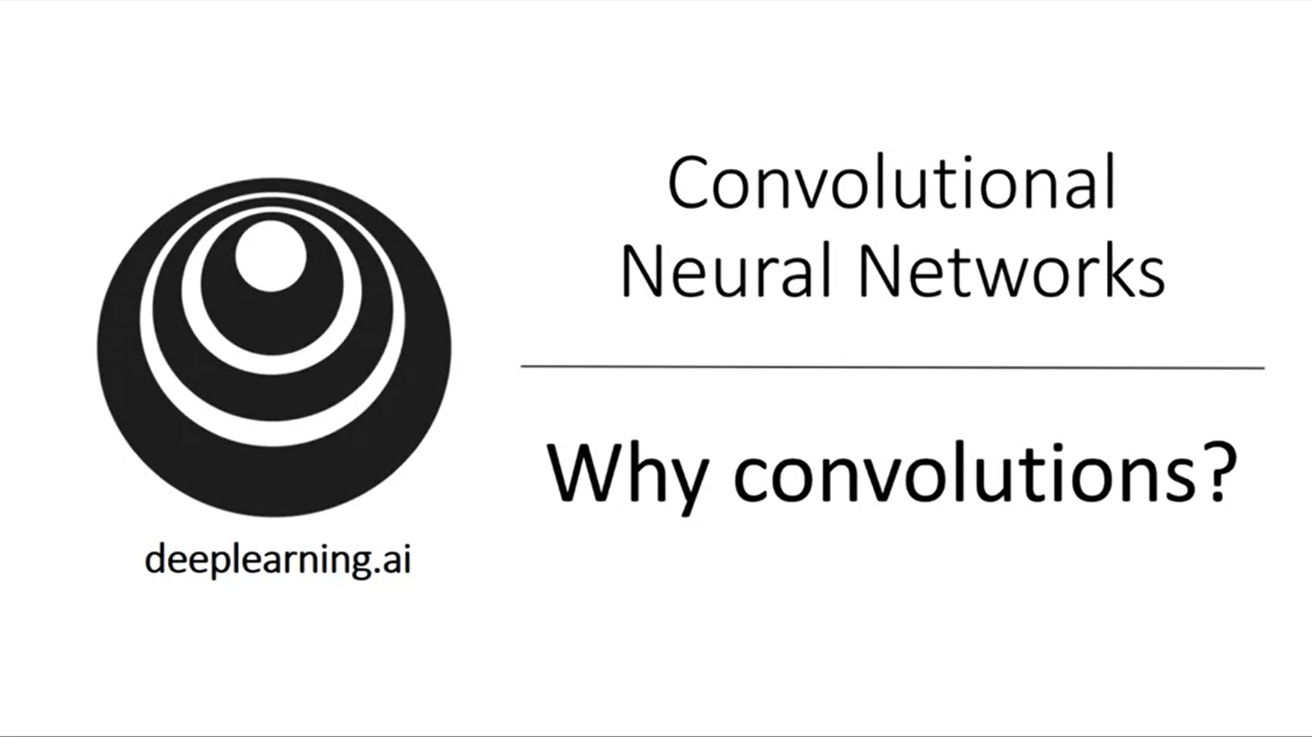

What are advantages of convolutions? Why are they so useful?

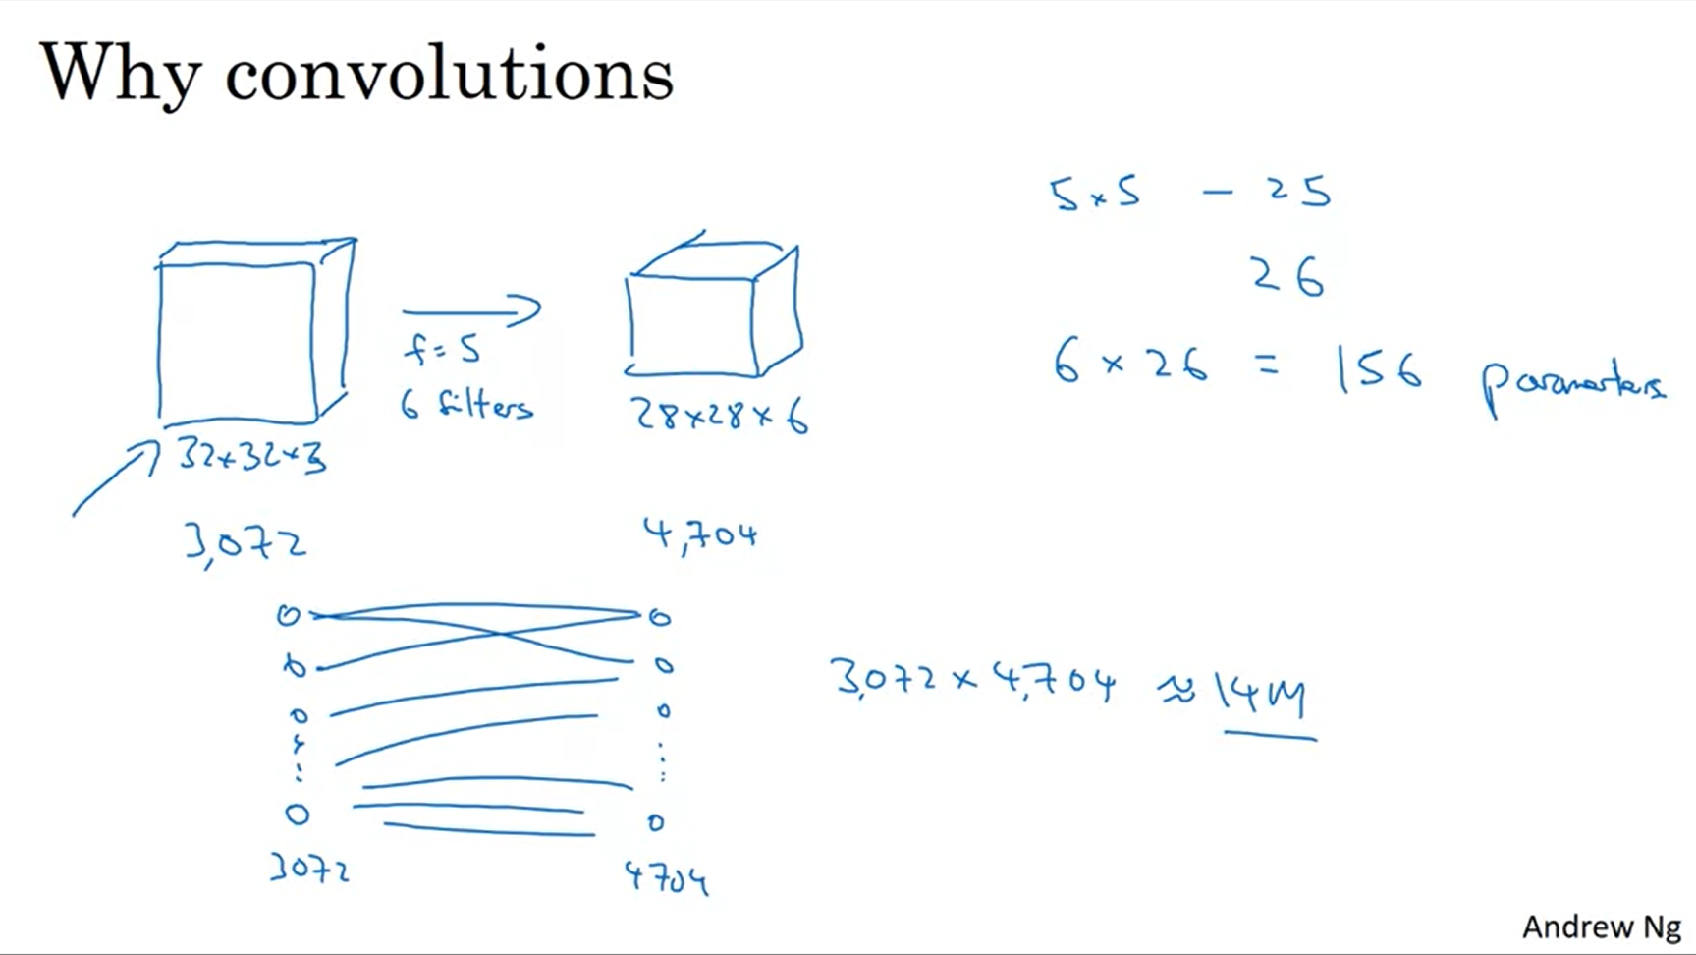

There are two main advantages of convolutions over fully connected layers: parameter sharing and sparsity of connections.

If you were to create a fully connected network for this setup, the parameters would be 14M. With a CNN it is only 156 parameters.

With a 1000x1000 image the parameters would get infeasibly large.

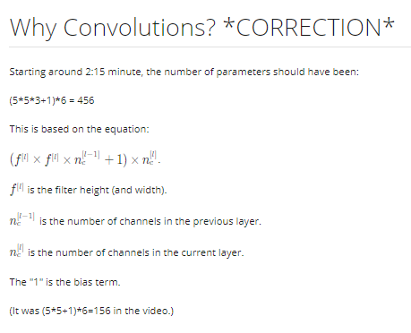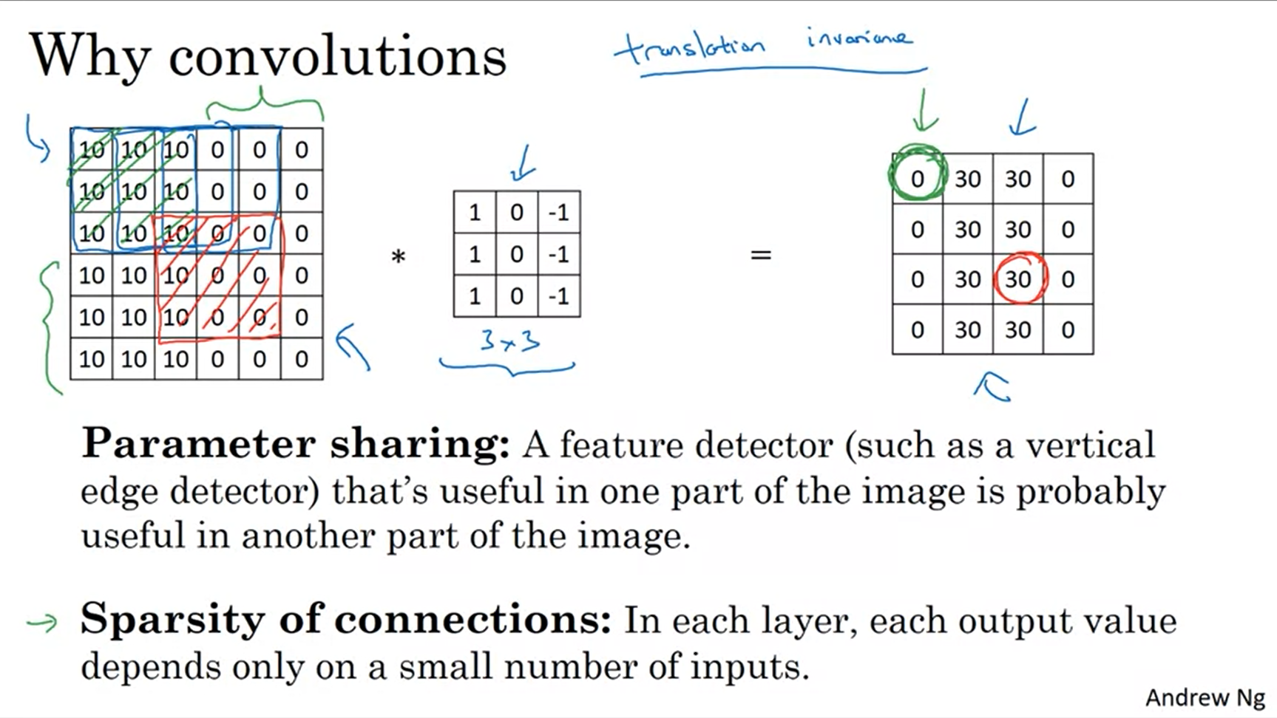

Parameter sharing might be useful for lower level and higher level features. Often times parts of an image look similar.

The red output only depends on the red input. The other pixels don’t affect the outcome at all. This is less prone to overfitting.

CNNs are very good at capturing translational variance. A picture of a cat shifted to the right is still a cat. This is encoded through a CNN. A CNN is more robust.

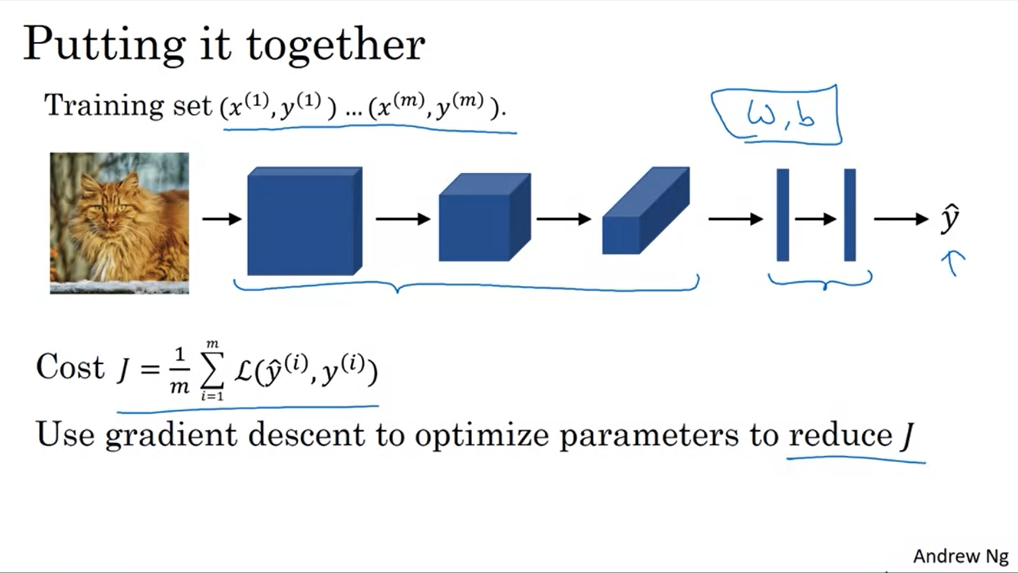

First conv and pooling layers, then fully connected layers. All of these have parameters that we want to optimize using backprop and gradient descent (or any other advanced optimization algorithm).